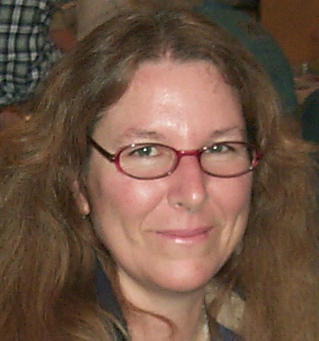

PRESIDENT’S MESSAGE
By: CJ Quitoriano

Hi all!
It's that time of year again!
We need nominations for officers! We also need Directors, and volunteers for the odd jobs that need filling.
If you would like to volunteer to run for office, or if you are interested in being a Director or any of the other positions, please let us know at the October meeting, elections are in November!
Dues are due in November as well, so bring your check books!
I hope everyone who made it out to Trona had a great time!
Ray and I couldn't make it this year, my granddaughter had a costume/birthday party for her 13th birthday, and we enjoyed that instead! Ray went as a werewolf and I was a penguin of course! Good fun!
What are you going to be for Halloween?
Don't forget to bring your show and tell item for the month.
See you at the meeting!
CJ

Rock of the Month!

Don't forget to bring something that you found, bought, made, or somehow obtained THIS MONTH to the meeting.
Display your item(s) and everyone will vote on their favorite display! At the end of the year the person winning the most times during the year will take the plaque home!

Calendar of Events!
10/14 Board Meeting
10/28 General Meeting
11/11 Board Meeting
11/25 General Meeting

Welcome to our new
Club Members!!!
Lucas Karnes
Olivia Miseroy
David & Cynthia Haven
(Jr.) Lana Haven
Terry Ryan
Chris & Paula Smith
(Jrs.) Josephine, Keenan
& Lauryn Smith

October Program
Hard Stone Carving Demonstration

Fun Facts
There are only four words in the English language which end in "dous": tremendous, horrendous, stupendous, and hazardous.
There are two words in the English language that have all five vowels in order: "abstemious" and "facetious."
"Dreamt" is the only English word that ends in the letters"mt".
A "jiffy" is an actual unit of time for 1/100th of a second.
The words “racecar”, “kayak”, and “level” are the same whether they are read left to right or right to left (palindromes).
The average person's left hand does 56% of the typing.
The longest word that can be made using the letters only on one row of the keyboard is “Typewriter”.
The longest word typed with only the left hand is
"stewardesses”.
The longest word typed with only the right hand is
"lollipop".
Leonardo Da Vinci invented the scissors.
Maine is the only state whose name is just one syllable.
No word in the English language rhymes with month,orange, silver, or purple.


Articles
Page 1 ……….President’s message
Page 1………..October Program
Page 1………..Calendar of Events
Page 1………..Rock of the Month
Page 1………..Welcome New Members
Page 2………..Refreshments
Page 2………..Club FIELD TRIP
Page 3………..Birthdays & Anniversaries
Page 3………..Club Website
Page 4 & 5....General Meeting Minutes
Page 5…….….Board Meeting minutes
Page 5………..CFMS News & Shows
Page 6………..AV G&M Board & Directors

October
Refreshments
CJ & Ray Q.
&
Ron James

Happy Birthday!
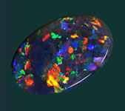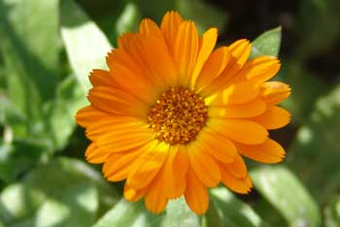
Opal Marigold

OCTOBER
10/9 CJ Quitoriano
10/14 Pamela Birge
10/29 Rick Guethein

Anniversaries

None Listed

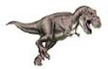Socrates
Keep this in mind the next time you are about to repeat a rumor or spread gossip.
In ancient Greece (469 - 399 BC), Socrates was widely lauded for his wisdom. One day an acquaintance ran up to him excitedly and said, "Socrates, do you know what I just heard about Diogenes?"
"Wait a moment," Socrates replied, "Before you tell me I'd like you to pass a little test. It's called the Triple Filter Test."
"Triple filter?" asked the acquaintance.
"That's right," Socrates continued, "Before you talk to me about Diogenes let's take a moment to filter what you're going to say.
The first filter is Truth.
Have you made absolutely sure that what you are about to tell me is true?"
"No," the man said, "Actually I just heard about it."
"All right," said Socrates, "So you don't really know if it's true or not.
Now let's try the second filter, the filter of Goodness.
Is what you are about to tell me about Diogenes something good?"
"No, on the contrary..."
"So," Socrates continued, "You want to tell me something about Diogenes that may be bad, even though you're not certain it's true?"
The man shrugged, a little embarrassed.
Socrates continued, "You may still pass the test though, because there is a third filter, the filter of Usefulness.
Is what you want to tell me about Diogenes going to be useful to me?"
"No, not really."
"Well," concluded Socrates, "If what you want to tell me is neither True nor Good nor even Useful, why tell it to me or anyone at all?"
The man was bewildered and ashamed.
This is an example of why Socrates was a great philosopher and held in such high esteem.

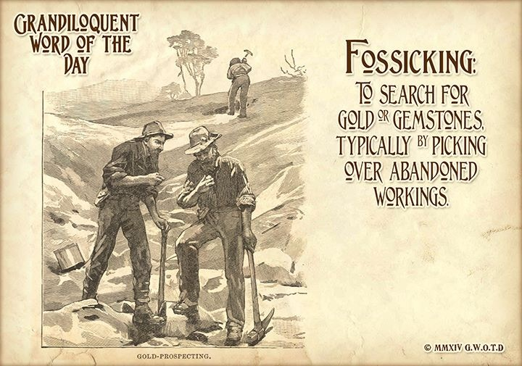

SLABS
The Club needs your help! We need any extra slabs you have laying around. The slabs will be used to make critters for the spinning wheel at the Poppy Festival-Our Show-Fair booth!
THANK YOU! THANK YOU! THANK YOU!

CLUB WEBSITE
www.avgem.weebly.com
You can check out the club’s website at: http://avgem.weebly.com. As I am able to get updated information, I update the website as well. And just a reminder - I welcome any help with photos from the general meetings and events, award winning items and winners, and field trips to help keep the website current. Rhonda


*REMEMBER *

ARTICLES FOR YOUR NEWSLETTER ARE DUE TO THE EDITOR BY THE 3rd SATURDAY OF EACH MONTH!!!

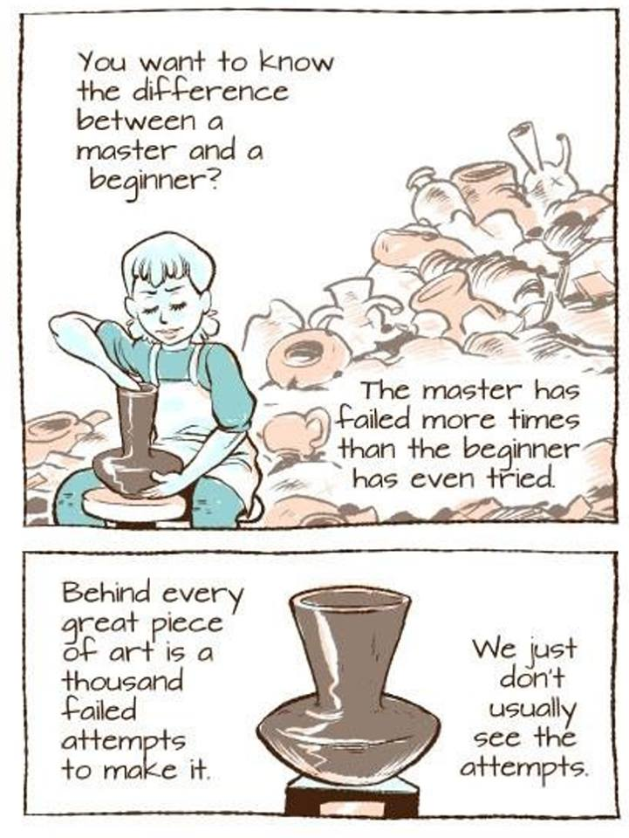

Antelope Valley Gem & Mineral
General Meeting Minutes
August 26, 2014 Minutes

Meeting brought to order at 7:09
members present - 22 guests - 19
Flag salute
Badge drawing was won by Gordon $10
New members were announced
Membership applications were handed out to those who wanted to join
CJ thanked all of those who worked at the Fair
Fair ribbons were won by Steve, Betty, Vivian, Danny and Carey
Field trip next month will be on Sept 20th to collect rose quartz. Information cards
were handed out. Meet at 6:30 at the Jack-in-the-box in Rosamond.
Trailer news. The club purchased a 23 ft trailer and show cases 36 large ones and 10
small ones. Thank-you to Gordon and Ray for picking it up.
Thank-you to Gordon for submitting a great article for the bulletin on his trip up to ﬁnd
Lapis.
Publicity - Ruth - meeting was published in the AV Press
Website - Rhonda - keeping it up to date
BREAK - ice cream and sale of 50/50 tickets
Treasurer report - Susan We made more at the Fair this year then we did last year.
ROCK BINGO was played and enjoyed by all.
50/50 drawing of $32.50 was won by Jenny Baker
Meeting adjourned at 8:30

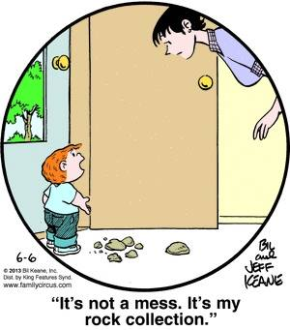

Antelope Valley Gem & Mineral Club
Board Meeting Minutes
September 9, 2014
Meeting brought to order at 7:30
Treasurerʼs report - everything is balanced
Directorʼs and ofﬁcerʼ insurance has been paid.
We will need to have additional insurance once the club house is up and running.
Susan will be making a purposed budget to be voted on by next yearʼs board
members.
Bulletin - we need articles and ways to encourage people to submit some.
Ruth H. is now the publicity chairperson
Jerry made a motion to accept last months minutes as written, Ray seconded it.
Federation Director - The next meeting is in Nov. in Visalia.
Camp Paradise was a success. Both weeks were full.
Field trip on the 20th to get rose quartz. Meeting at the Jack-in-the-box in Rosamond
at 6:30 and leaving by 7:00.
Programs - unknown what the program will be this month.
Fair - We took in more then we did last year.
Old business - the new trailer needs to be registered
Meeting adjourned at 8:55

2014 Local CFMS Show Listings

October 25 & 26: CAYUCOS, CA
San Luis Obispo Gem & Mineral Club
Cayucos Vets Hall
10 Cayucos Drive
Hours: 9 am – 5 pm Daily
Kim Patrick Noyes (805) 610-0603
kimnoyes@gmail.com
www.slogem.org

November 1 & 2: OXNARD , CA
Oxnard Gem & Mineral Society
Oxnard Performing Arts Center
800 Hobson Way
Hours: Sat. 9 – 5; Sun. 10 – 4
Miriam Tetreault (805) 642-5779
ml_tetreault@hotmail.com

November 1 & 2: RIDGECREST, CA
Indian W ells Gem & Mineral Society
Desert Empire Fairgrounds
520 S. Richmond Road
Hours: 9 AM 5 PM Daily
John DeRosa (760) 375-7905
http://indianwells.weebly.com

November 8 & 9: ANAHEIM, CA
American Opal Society
The Phoenix Club-Festhalle
1340 S. Sanderson Avenue
Hours: Sat. 9 6; Sun. 9 5
Veronica Purpura (714) 501-9959
info@opalsociety.org
www.opalsociety.org

November 8 & 9: SACRAMENTO, CA
Sacramento Mineral Society
Scottish Rite Temple
6151 H Street
Hours: Sat. 10 -5; Sun. 10 4
Alyssa Mesiznger (916) 662-5819
Cell (916) 205-4441
gemshow@sacramentomineralsociety.org
sacgemshow.com

November 22 & 23: SANTA CRUZ, CA
Santa Cruz Mineral & Gem Society
Live Oak Grange Hall
1900 17 Avenue th
Hours: 10 AM 5 PM Daily
Julia Cornblatt (831) 687-0509
julia.cornblatt@gmail.com
www.scmgs.org

