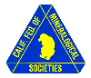
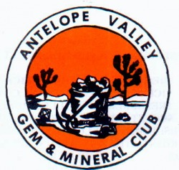 CHIP ‘N’ TUMBLE

_______________ _____ ________ _____________ November 2013

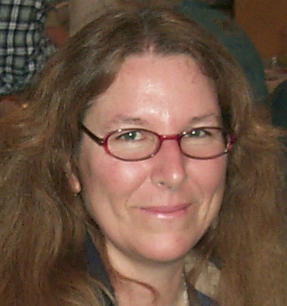

PRESIDENT’S MESSAGE
By: CJ Quitoriano

Hi everyone!
I hope to see you all at the next meeting.
We will be discussing the show a little and maybe planning some critter building days.
I would also like to discuss our junior program. We are getting more children and I would like to have some ideas about how we can keep the young ones entertained during the meetings. Any ideas? Bring them with you!
Have a great week and see you next Tuesday! CJ

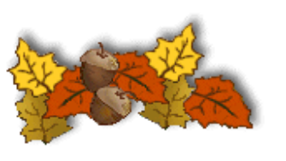

Calendar of Events!
10/22 General Meeting
11/12 Board Meeting
11/16 Field Trip No Cady Mount.
11/26 General Meeting

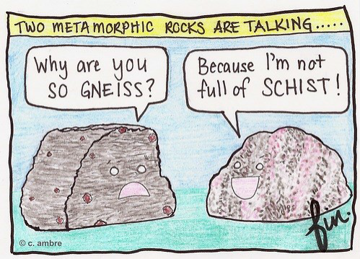

October Rock of the Month!
Don't forget to bring something that you found, bought, made, or somehow obtained IN THE LAST THE MONTH to the meeting. No fair bringing something that you obtained before, our last meeting!
Display your item or items! The people attending the meeting will vote on the winner. Who will receive the plaque? At the end of the year, the person who wins the plaque the most times will get to keep the plaque.

MEMBERSHIP DUES ARE DUE!
It is that time of year again.
Dues for 2014 are due by December 31st.
You may pay your dues at the
October, November or December Meeting.
Annual dues are:
Adult - $15 each & Juniors - $5 each

OCTOBER PROGRAM
Beginners Silver Smithing Project
By: Ron James

**Mark your calendar**
Antelope Valley
Gem & Mineral
2014 show dates!
April 26-27, 2014


Articles
Page 1 ……….President’s message
Page 1………..Calendar of Events
Page 1………..Rock of the Month
Page 1………..2014 Dues are due
Page 1………..October Program BSSP
Page 1………..2014 Show Dates
Page 2…………November Field Trips
Page 2…………Club Website
Page 2………..Refreshments
Page 2………..Minutes not available
Page 3………..State Fossil
Page 3………..Picture Sept. Meeting
Page 3………..Club Scrapbook
Page 3………..Birthdays & Anniversaries
Page 3………..CFMS Shows
Page 3………..Slabs are needed
Page 4……….AV G&M Board & Directors

FIELD TRIPS
Danny & Vivian Watts
November-16
To the North Cadys Mountains
We will be meeting at 8:00 am at Diamond Pacific
2620 W. Main Street in Barstow
We will be rockhounding for:
Angel Wing/Agate/Jasper
December - No Fieldtrip



WEBSITE
(http://avgem.weebly.com)
There's a new page on the website - it's for Club Bulletins. The most current newsletter will be first on that page. One of the buttons below it lets you enlarge it to read it online, or you can download it, along with earlier issues, from the links below.
A reminder - if you participate in any club activities and snap some photos, will you send me a copy?
Rhonda
Refreshments
October
REFRESHMENTS
Will be provided by?
Thank you!

Antelope Valley Gem & Mineral Club
September General Meeting Minutes
& October Board Meeting Notes
Not Available at this time!

*REMEMBER *

ARTICLES FOR YOUR NEWSLETTER ARE DUE TO THE EDITOR BY THE 3rd SATURDAY OF EACH MONTH!!!
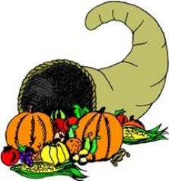
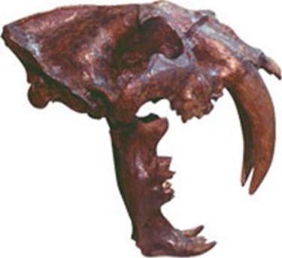
California State Fossil
The California State Fossil is known as the Saber-Toothed Cat. They lived about 1.8 million to 11,000 years ago, stood 3 feet high and weighed about 600 pounds, and are best known for their 8-inch long canine teeth. The bones of many of these animals have been found in the La Brea Tar Pits in Los Angeles.

September’s Meeting Program was a hit!

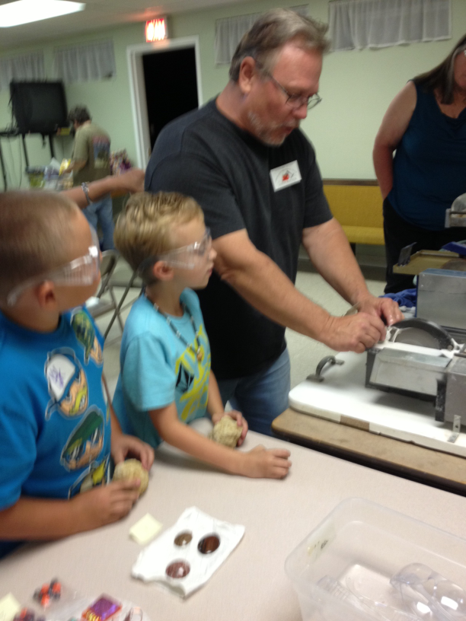

2013 Club Scrapbook Committee
Lorelei Paland

2013!
Please write letters to your Congressman regarding park and land closures, etc. I will need a copy of your letter and also a copy of any letter sent back to you.
I also need any information you pick up at and about other Shows.
You can either give me the info at the meetings or email me at rhinesiren@att.net.
Thank you so much.
Lorelei~

November
BIRTHDAYS & ANNIVERSARIES

Happy Birthday!

NOVEMBER

Chrysanthemum
Danny Watts November 6
Jerry Paland November 12
Mary Black November 13
Ellen Niduvitch November 29
Elaina Cologna November 30

Happy Anniversary
Danny & Vivian Watts November 21

2013 Local CFMS Show Listings

October 19 & 20: WHITTIER, CA
Whittier Gem & Mineral Society
Whittier Community Center
7630 Washington Avenue (at Mar Vista)
Hours: 10- 5 Daily
Marcia Goetz (626) 260-7239
joenmar1@verizon.net

November 2 & 3: RIDGECREST, CA
Indian Wells Gem & Mineral Society
Desert Empire Fairgrounds
520 South Richmond Road
Hours: 9 – 5 Daily
John DeRosa (760) 375-7905
Vickie Black (760) 371-4416

SLABS
The Club needs your help! We need any extra slabs you have laying around. The slabs will be used to make critters for the spinning wheel at the Fair!
THANK YOU! THANK YOU! THANK YOU!

