
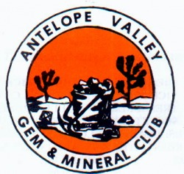 CHIP ‘N’ TUMBLE

_______________ _____ ________ _____________ May 2014



PRESIDENT’S MESSAGE
By: CJ Quitoriano

Hi everyone!
First off, I want to say I was sorry for the panicky email I sent out about the Poppy Festival signups! I was looking at the wrong month and thought the meeting was after the event! Oops!
So, we will have signup sheets for both the show and the Poppy Festival at the meeting on Tuesday night.
We will be having an ice cream social and will have a demonstration on how to set up your case for the show! I am hoping that each of you will be able to put a case in, even if it's stuff you bought? We want to show the world what we do!
I will have exhibit entry forms at the meeting.
I want to thank all of those who came to help out at the work day and opt luck at our house! We had some yummy food and stuffed a LOT of bags!!
Thank you to:
Lorelei & Jerry
Carey
Gordon
Mary B
Ron L and his friend Roxanne
Elaine
Steve W
Danny & Vivian
Shelley
Sandy and her sister
I know I am forgetting someone, and I feel really bad about that! I need to have a sign in sheet at these things so I know who comes!!
Thank you all sooo much for helping out and bringing all that yummy food!
We are going to the Tropico mine this weekend, the 19th for a private tour!
We are meeting at my house at 9am and leaving for the mine at 9:30.
There is only a small group going so far, so if you want to come, be there or be square!
I hope to see you all at the meeting!
CJ
APRIL PROGRAM
Demonstration on setting up a display case!
Sign-ups for the Poppy Festival Booth & Our SHOW!

Calendar of Events!
4/22 General Meeting
5/13 Board Meeting
5/27 General Meeting
5/30-6/1 CFMS SHOW-PAMONA

April Rock of the Month!
Don't forget to bring something that you found, bought, made, or somehow obtained THIS MONTH to the meeting.
Display your item(s) and everyone will vote on their favorite display! At the end of the year the person winning the most times during the year will take the plaque home!

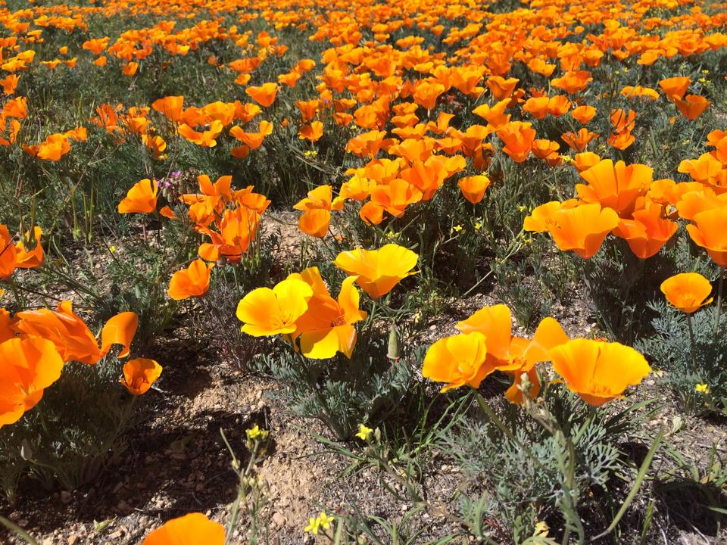



Articles
Page 1 ……….President’s message
Page 1………..March Program
Page 1………..Calendar of Events
Page 1………..Rock of the Month
Page 2………..Refreshments
Page 2…………Field Trips
Page 3…………Club Website
Page 3………..Slabs are needed
Page 3………..Birthdays & Anniversaries
Page 4…….….Meeting minutes
Page 5………..CFMS News & Shows
Page 6……….AV G&M Board & Directors

FIELD TRIPS

APRIL 19 – Tropico Mine Tour

Meet at CJ & Ray’s house

Space is limited
Please RSVP to CJ!

If you have an idea for a Club Field Trip, please let CJ or another Board Member know about it.

April
REFRESHMENTS

ICE CREAM SOCIAL
Sponsored by the AV G&M Club
Yummy Yummy!!!!

Triboluminescence
From Mini Miners Monthly Volume 8, Number 3
What you need:
Two clear quartz crystals.
You don’t want to use really nice, collector
quality crystals. Get two average “I don’t care if
I damage them” crystals, because, well, you are
going todamage them.
What to do:
Hold the edge or termination of one crystal on the face of the second crystal. Push the two crystals together as hard as you can. While still pushing
them together, rub the first crystal across the face of the second crystal. You probably won’t see anything with the lights on... So now, turn the lights off in your room and repeat the steps. You will see a flash of yellow light inside the second crystal!
What’s happening here?
This is a special property called “Triboluminescence. Luminescence means “light”.
Tribomeans “to rub, so, this is light created by rubbing, in this case, one crystal against another. Scientists really do not know why this works. It could have something todo with the pulling apart of
electrical charges that quickly reconnect. More fun with Triboluminescence. You cancreate a flash of light with Wintergreen Lifesaver™candy. (This only works for wintergreen though.) Put onein a plastic bag and squeeze it quickly with a pair of pliers. You
will create a flash of light. This only works for
Wintergreen though. This also works if you bite
Down on the candy really hard and fast with
your teeth with your mouth open, in the dark.
But then, only your friends will see the light!

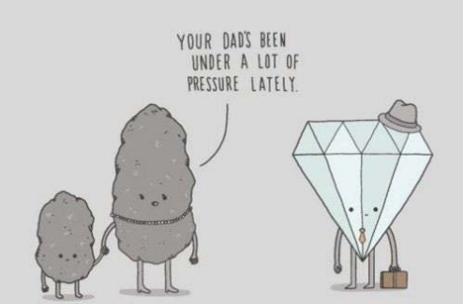

CLUB WEBSITE
www.avgem.weebly.com
Just a reminder that any help you can be taking photos on any of the field trips or at the meetings, would be awesome! Just send me a digital copy (email address is on the last newsletter contact page). Helps to keep the website fresh, and unfortunately, we have been unable to make so many of the events ourselves lately. So your help is much appreciated! Thanks, Rhonda


SLABS
The Club needs your help! We need any extra slabs you have laying around. The slabs will be used to make critters for the spinning wheel at the Fair!
THANK YOU! THANK YOU! THANK YOU!

*REMEMBER *

ARTICLES FOR YOUR NEWSLETTER ARE DUE TO THE EDITOR BY THE 3rd SATURDAY OF EACH MONTH!!!

HAPPY
BIRTHDAY & ANNIVERSARY

Happy Birthday!
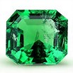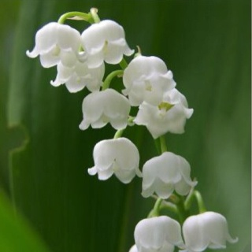
Emerald Lilly of the Valley
Garnet Carnation
May
5/1 David Walblom

Happy Anniversary
???????????

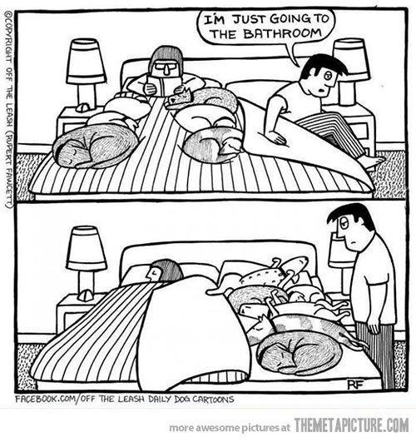



Antelope Valley Gem & Mineral
General Meeting Minutes
March 25, 2014 Minutes

The meeting was called to order at 7:08 p.m.
those present were 20 members and 6 guests. The guests were Greg and Marilyn Buchanan, Dixon Rupp, Don Coleman, Alex Borchest and David Wheeler.
Gordon make a motion to accept the minutes as posted and Ray seconded Door prizes were won by Everett, Bonnie and Don Coleman (guest)
Badge drawing - Don Reed - He wasnʼt here so it will be $10 next month.
The Program is the second half of the movie we watched last month
Vivian Watts was voted in as vice president
BREAK
Bulletin - We need members to submit articles maybe remarks on a field trip you
attended.
Federation Director - Show coming up May 30 - June 1.
Would like more people to enter cases. Steve is entering one.
Field trip this month was to Kramer Junction
Rockhound of the month Gordon brought rocks he got on the field trip, agate, palm root and reeds
Vivian - wire wrapped jewelry and Danny - sphere of mexican crazy lace agate.
Membership - One new member, Harry Becker
No program next month instead ice cream social and discussion on upcoming Rock Show
Field trip for April is on the 19th. Shelley got us a tour of the Tropico Gold mine.
Publicity - Ray is now temporarily in charge until some one volunteers.
We also have tshirts for sale. Get yours now to wear while working the Show!
Scholarships - We have 2 so far
Spring Show - We need to make more critters
Jerry is going to make a mine and mine cart
We will need 16 cases and tables Cost of $125 to go to Barstow Club Gordon will pick them up
Poppy Festival - Steve is in charge, he needs help. Sign ups next meeting.
New Business - Volunteers needed to work on the shop, build shelves in closet.
Workshop on April 5th at Ray and CJʼs Bag stuffing and pot luck starts at 10:00
Next months board meeting at Jerry and Loreleiʼs on April 8th
50/50 drawing of $27 was won by Marilyn Buchanan (guest)
Rockhound of the month went to Vivian
Meeting adjourned at 8:47 p.m.


Antelope Valley Gem & Mineral Club
Board Meeting Minutes
April 8, 2014

Meeting called to order at 7:15
Those present Ray & CJ, Susan & David, Steve and Jerry & Lorelei
Jerry made a motion to accept the minutes as written, Steve seconded
Bulletin = Need articles and minutes
Federation news - Zzyzx just finished. Every one had a good time. There were three or four field trips during the week.
Field trips - Tropico Gold Mine on April 19th. Meet at Ray and CJʼs at 9:00
Refreshments this month - ice cream social
Programs - CJ bringing her display case to show people how to set one up.
Publicity - Ray will call the paper to put in an as for the show.
Scholarships - One so far
Website - Still up and running well
Poppy Festival - Insurance papers sent in
Steve doesnʼt have enough chains for the pendants. Susan said she will get some. Prices were discussed and set for all items being sold.
Show - Over 20 vendors so far. Still need to pay the school
We also still need a PA system. Sign ups for working will be at the next meeting and fliers will be handed out. Ray will bring the meat to barbeque. The Dinosaur Man, Richard Wade, confirmed he will be there.
Next board meeting to be held at Steve’s house on May 13th.
Meeting adjourned at 8:20 p.m.



2014 Local CFMS Show Listings

April 26 & 27: THOUSAND OAKS, CA
Conejo Gem & Mineral Club
Borchard Park Community Center
190 Reino Rd. at Borchard Rd.
Hours: 10-5 Daily
Rob Sankovich (805) 494-7734
rmsorca@adelphia.net
http://www.cgamc.org/

May 2, 3 & 4: BISHOP, CA
Lone Pine Gem & Mineral Society
Bishop Fairgrounds
Sierra Street
Hours: Fri. 5-10 p.m.; Sat. 9-7; Sun. 10-3
Steve Mobley (760) 793-6025
steve@littlebearrocks.com

May 3 & 4: ANAHEIM, CA
Searchers Gem & Mineral Society
Brookhurst Community Center
2271 W. Crescent Avenue
Hours: Sat. 10-5; Sun. 10-4:30
Robert & Sharon Burson (562) 860-5938
Cell (562) 706-2054
bursonrocks@verizon.net
searchersrocks.org/

May 3 & 4: PASO ROBLES, CA
Santa Lucia Rockhounds
Pioneer Park & Museum
2010 Riverside Drive
Hours: 9 a.m.-5p.m. Daily
Kim Noyes (805) 610-0603
kimnoyes@gmail.com
www.slrockhounds.org

May 3 & 4: YUCAIPA, CA
Yucaipa Valley Gem & Mineral Society
Scherer Senior Center
12202 First Street
Hours: Sat. 10-6; Sun. 10-4
Lee Peterson (909) 794-0731
res09ayd@verizon.net
www.yvgms.org

May 10 & 11: LANCASTER, CA
Antelope Valley Gem & Mineral Club
Lancaster High School
44701 – 32nd Street West
Hours: 9 am – 5 pm Daily
CJ Quitoriano (661) 209-9092
cjq_62@yahoo.com
www.avgem.weebly.com



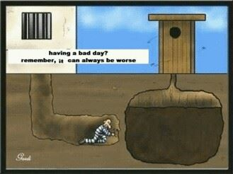

California's Gem
&
Mineral Bounty
PRESENTED BY THE PASADENA LAPIDARY SOCIETY AND THE
CALIFORNIA FEDERATION OF
MINERALOGICAL SOCIETIES
This is THE Gem and Mineral show of
the year!
cfms2014show.com/Show_Packet.html
HOURS:
Friday, May 30th:
10:00 AM -5:00 PM
Saturday, May 31st:
10:00 AM -5:00PM
Sunday, June 1st:
10:00 AM -4:00 PM

