_______________ _____ ________ _____________ June 2015

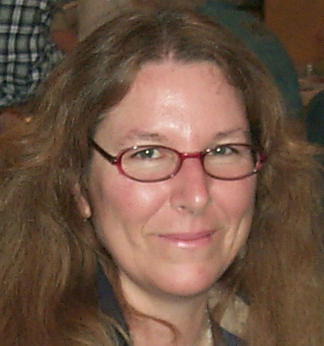

PRESIDENT’S MESSAGE
By: CJ Quitoriano

Hello!
I hope everyone was able to make the field trip this month!
Next month some club members will be joining another club for a trip to Cerro Gordo, our new field trip leader, Paul Hobbs, will have the information at our next meeting.
Ray, Jerry, and Jim are going to be working on the trailer and getting a list together of what all is needed to be done, I'm sure they would love to have some help...give them a call if you have some time to spare!
Don't forget to bring a rock or something that you made or found or bought this month for the Rockhound of the month competition. For new members, you will be asked to describe what your item is and how you obtained it, and everyone votes for their favorite item during the break. The winner gets to take the plaque home for the month.
Thank you to Steve Wittick for putting on the program last month, I hope he has inspired everyone to enter a case in the fair this year! It would be great if we could fill up all the cases!
I hope everyone has a great week and we shall see you at the meeting!
CJ

THE CLUB HAS A NEW E-MAIL

avgemclub@gmail.com

Calendar of Events!
5/26 General Meeting
6/9 Board Meeting
6/23 General Meeting
7/14 Board Meeting
7/28 General Meeting
8/21-30 A V Fair Club Booth

********************************
May Program

*CRYSTAL GROWTH*

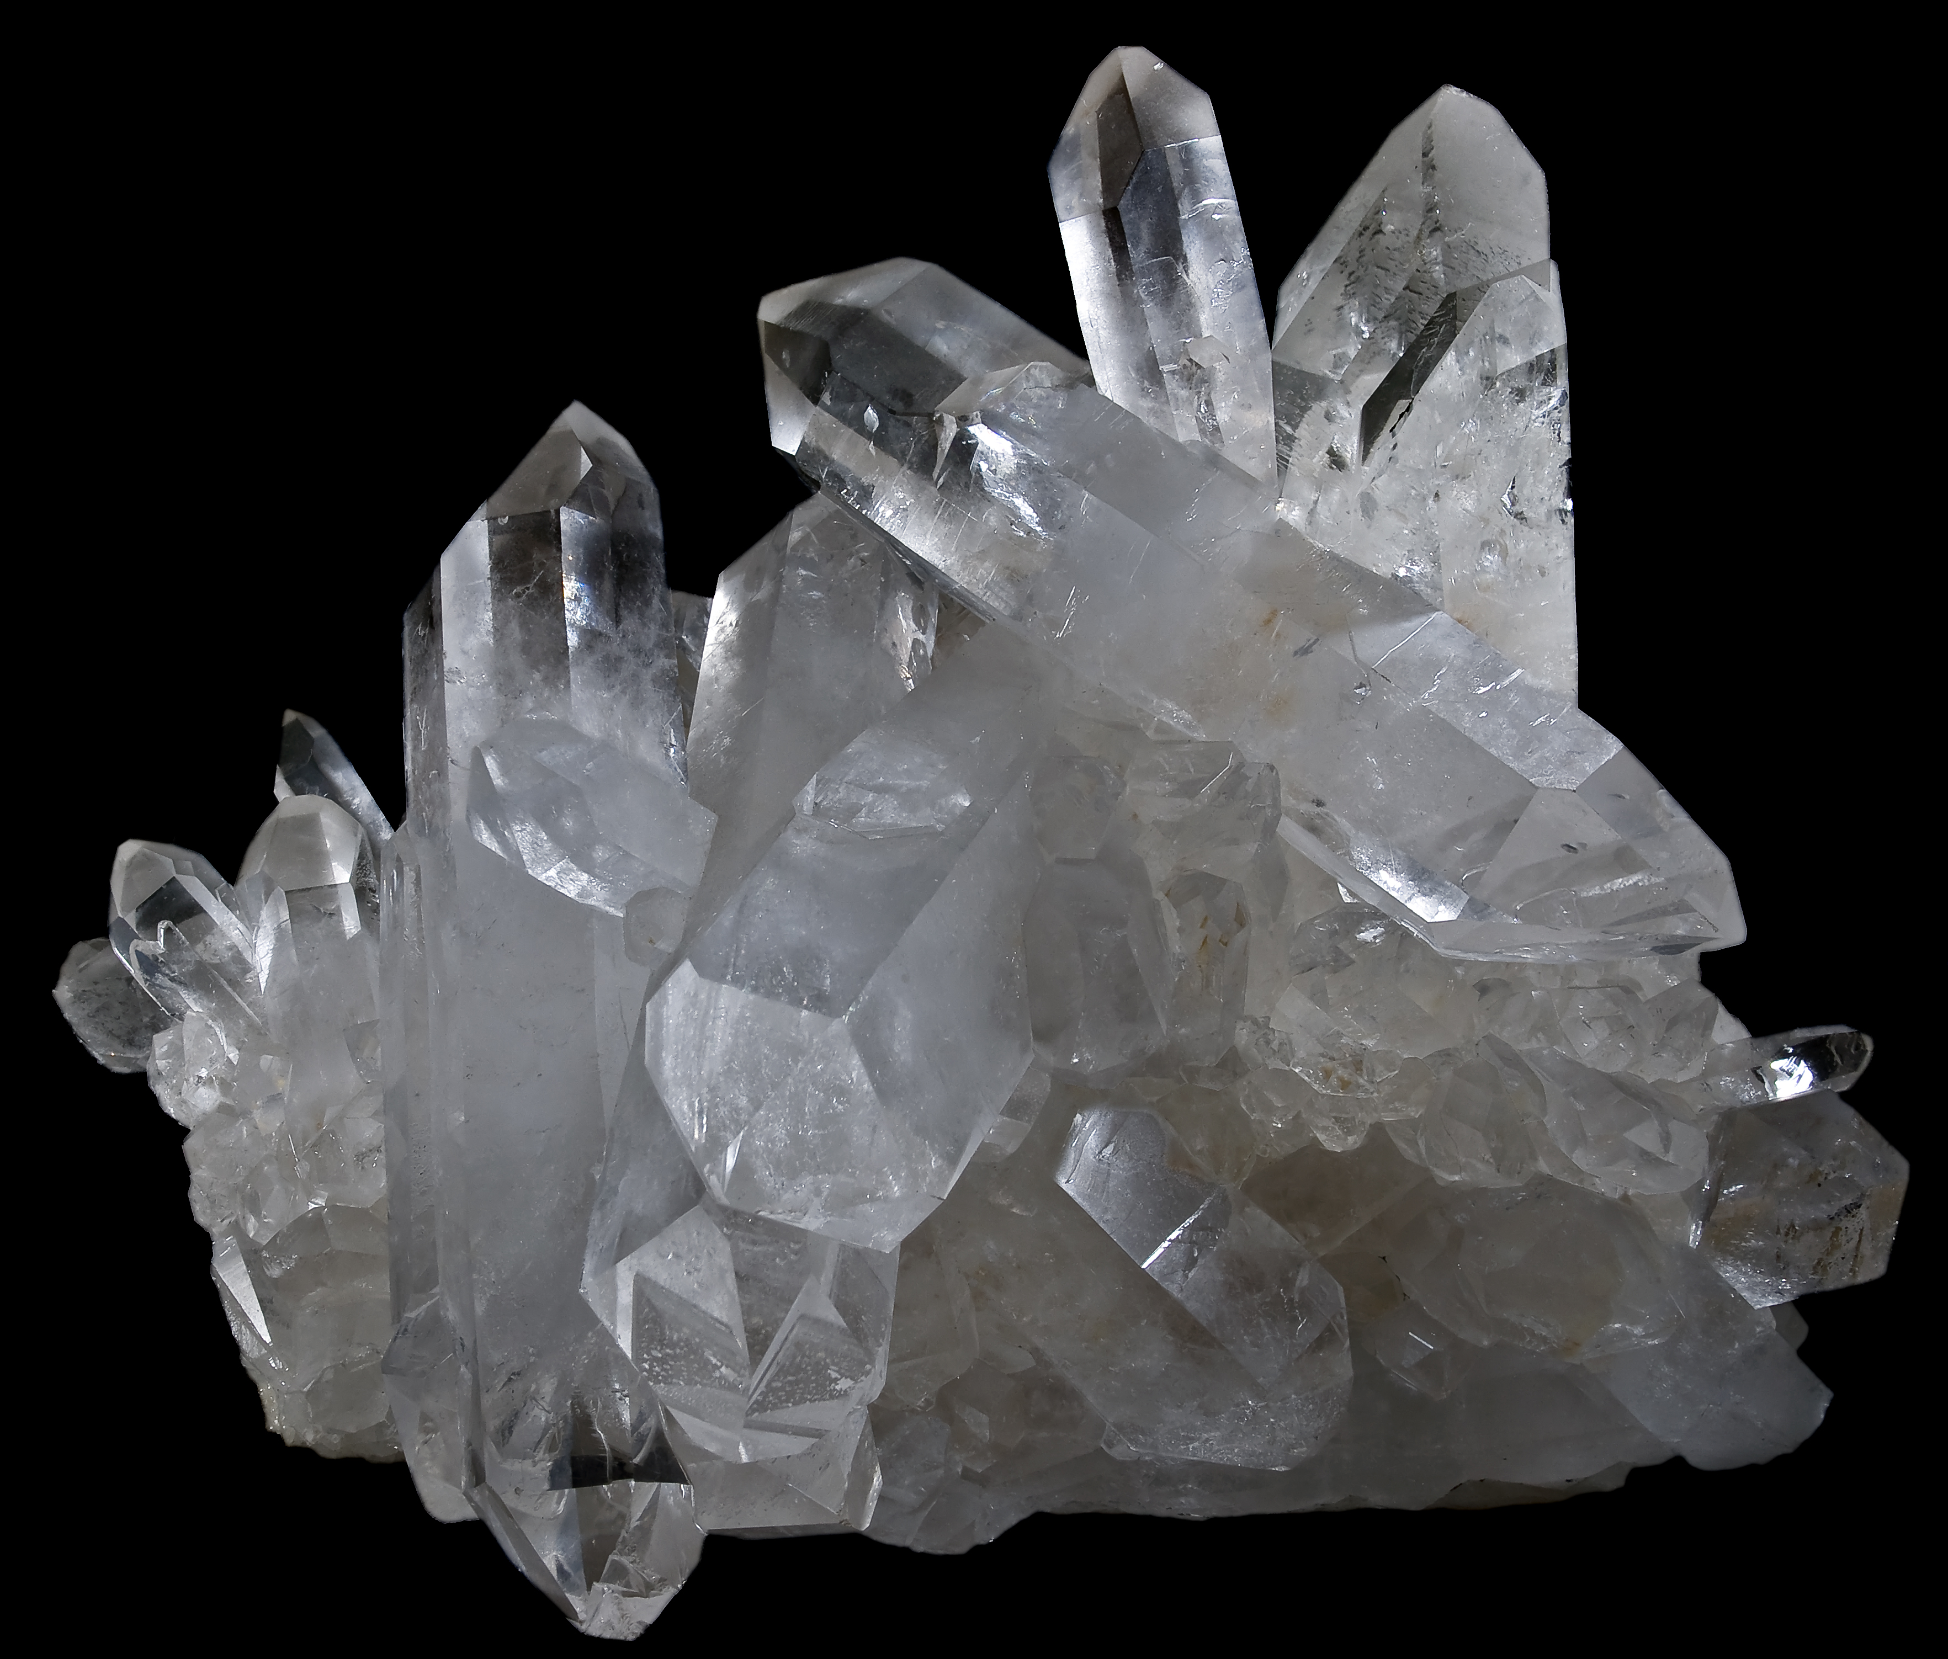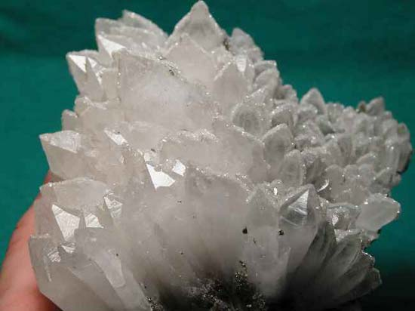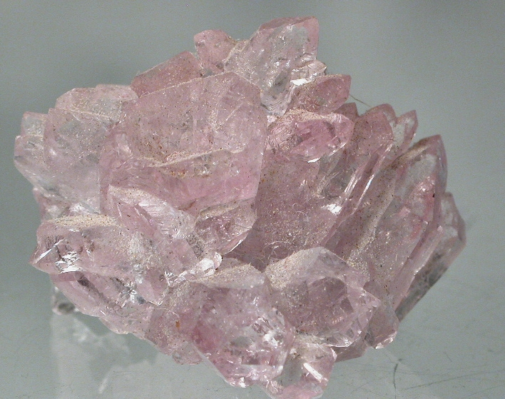

By: Jonathan Numer
********************************

May Refreshments

Snacks: Christine Janicki
CJ Quitoriano

Drinks: Gordon Butler

Articles
Page 1 ……….President’s message
Page 1………..May Program
Page 1………..Refreshments
Page 2…………2015 Show Highlights
Page 3………..FIELD TRIPS
Page 4………..Birthdays & Anniversaries
Page 4………..West Mojave (WEMO)
Page 5………..Meeting minutes
Page 5………..General Meeting Minutes
Page 5 & 6….Board Meeting Minutes
Page 6……….CFMS Local Show Listing
Page 7………..AV G&M Board & Directors

“2015 CLUB SHOW”
What a Great Show! Deapite the nasty weather the show was a success!

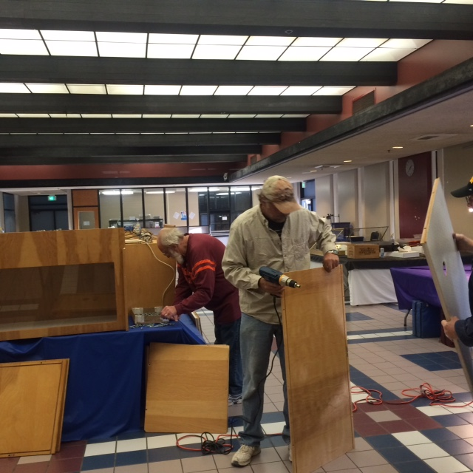
First set up – Club’s New Cases

[LA-Rocks] Yucaipa and Lancaster Thank You
Sherry and I want to say thank you to the Lancaster and Yucaipa clubs for two greats shows in the past two weeks. It shows well the effort the clubs put into
these events. We appreciate the time that club members volunteer. Tim - Bustin Glass and Minerals

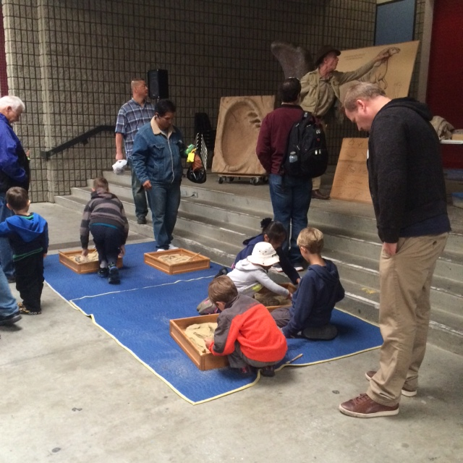
The Dinosaur presentation was a hit!

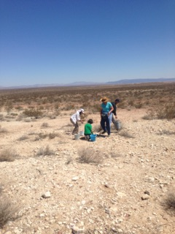
The Kramer Junction field trip was GREAT!

Thank you to Everyone!

Field Trips by Paul Hobbs

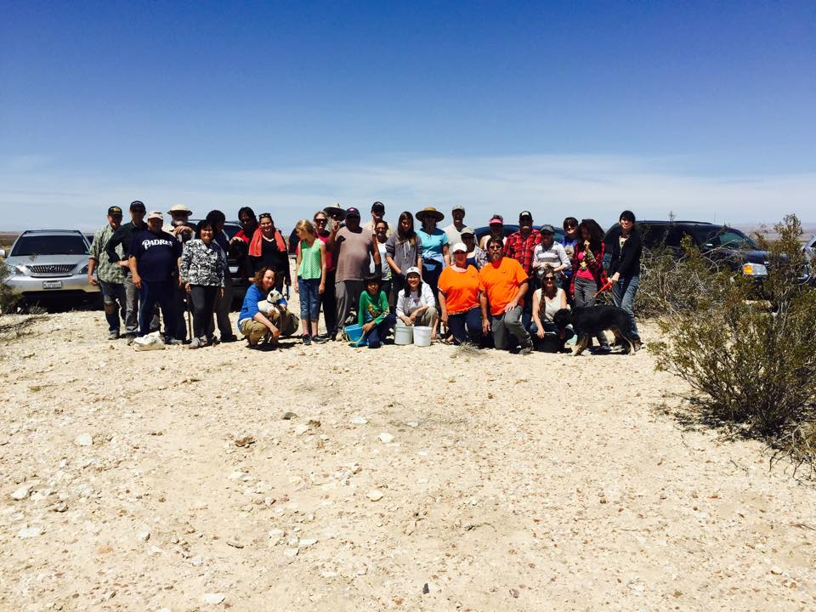

The field trip to Kramer Junction 4/26 in conjunction with the club show was well attended with 32 Rockhounds in attendance, including several Jr Hounds. One woman who traveled with her children from Los Angeles said she was debating between the Searcher’s show, which was the weekend after ours, and our show, but chose the Antelope Valley Gem show because of the associated field trip. Thanks to Ron Lawrence for all the years of providing a great example as a field trip leader and for helping me lead the trip.
Several of you expressed interest in going to the Kramer Junction area. We will schedule another trip in the fall when the weather cools off. One of the sites at Kramer Junction is threatened under WEMO. Please be sure to check your emails for information and comment to keep this awesome collecting site open.

Our next field trip will be to: Cerro Gordo
Sunday 6/28/15 as is hosted by the Lone Pine Club. This trip affords the opportunity to collect minerals on the dumps of a privately owned silver ghost town/mine. The history is interesting and the scenery is beautiful.

Date 6/28
Time 8:00 am
Meet at Lee's Frontier Chevron in Lone Pine.
1900 S Main St
Lone Pine, CA 93545

Fee- 5.00 + 5 pieces of fire wood + 5 gallons of drinking water PER PERSON. (More is always appreciated by the caretaker at Cerro Gordo).

Vehicles: 4wd High-clearance vehicles are recommended, with low gearing for the last 15 miles of the trip, which takes about 45 minutes from Lone Pine. This road is steep but well graded dirt road (9 miles with 5000 elevation gain). Car pooling can be arranged at Chevron station.

Tools to bring: small hand rake (three prong garden tool) for scraping through the tailings, spray bottle, shovel, rock pick or hammer, collecting bag or bucket, wrap for your specimens, sturdy boots, sunscreen, hat, and plenty of drinking water.

Bring water and lunch. There is no place to buy food once you leave the meeting place. Cerro Gordo is at an elevation of 8,300ft. It'll be several degrees cooler than the valley floor. The temperature can either be hot or cold so plan accordingly.

You need to climb up a steep hill, at a high elevation, to get to the collecting. It isn't a far walk, but all the collecting is done on steep hills. It is a moderately difficult trip.

Historic California has some great historical info on the town @ http://www.explorehistoricalif.com/cerro_history.html. There is also the Friends of Cerro Gordo Facebook page that has great info. You can find a list of the many mineral found at Cerro Gordo on
MinDat - http://www.mindat.org/loc-257101.html

MAY
HAPPY BIRTHDAY
& ANNIVERSARY

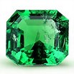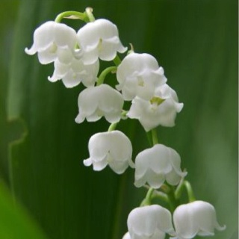
Emerald Lily of the Valley

Birthdays
5/1 David Walblom

Anniversaries
5/25 Chris & Paula Smith

CLUB WEBSITE
www.avgem.weebly.com
The website is slowly becoming more 'alive' again! In case you don't have it, here's the website address: http://avgem.weebly.com. It still really helps when members can send me photos taken on Field Trips, meetings, etc., since we don't make them all. We hope you find it helpful and informative, and I welcome suggestions! Rhonda

West Mojave Travel Management Plan or WEMO

West Mojave Travel Management Plan or WEMO has been in the works for years. Essentially, this plan aims to identify every single dirt road in the desert and designate only certain routes as open. Any road not marked open, will be considered closed. Obviously this plan can have a major impact on Rockhounds ability to access collecting sites and locate new ones. (Yes there is still spots to be discovered out there).

I urge all of you to check out the WEMO maps and make sure the roads to your favorite collecting spots marked open. I have found two major problems in the areas I know, one being the main site at Kramer Junction and the other being the Calico Mountains. Another significant road at Lavic Siding is also at risk, as brought to my attention by Ron Schiller of the Indian Wells Club. These roads to spots Rockhounds have been recreating in for decades are to be CLOSED if we don’t speak up. It is very important we take the time to comment so the BLM knows we use these roads and don’t want them closed. I will be sending out an email on how to comment on these three sites. I cannot stress enough how important it is to check the maps in areas you collect in, otherwise, one day you will go out there only to find the road CLOSED. http://www.blm.gov/ca/st/en/fo/cdd/west_mojave__wemo/wmDEIS.html
Comments must be made no later than JUNE 4!!!!!

If you need any help or want me to check roads to site for you, just email me @ slipform.rh@gmail.com. Navigating the maps can be daunting, but once you spend some time on there, it isn’t so bad.

Thank you for your anticipated participation in this very important matter.

Ruth Hidalgo

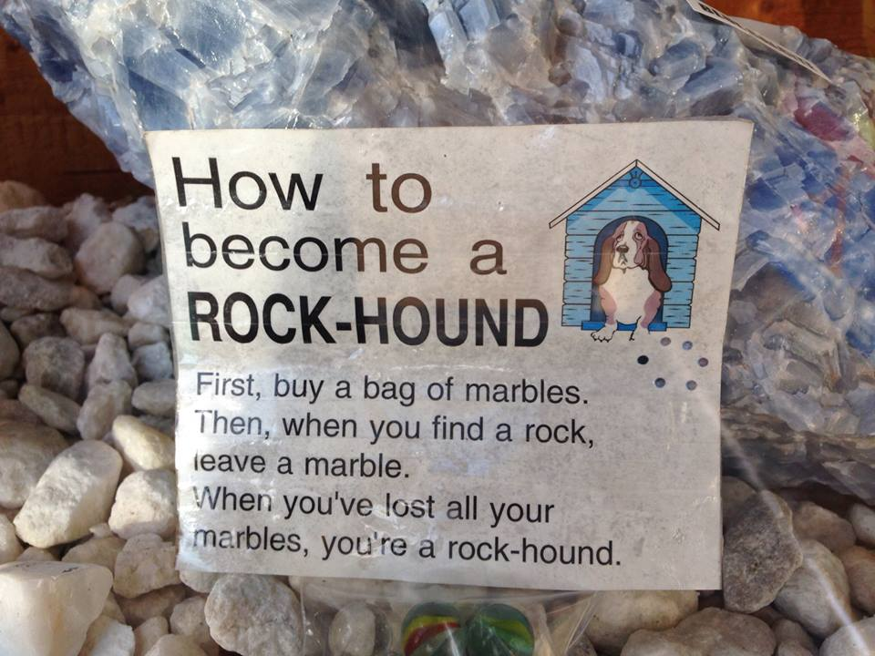

Antelope Valley Gem & Mineral
Aprilv28, 2015 General Meeting Minutes

The meeting was brought to order at 7:07p.m.
Flag Salute
Those present - members - 32 Guests - 10
Steve made a motion to accept the minutes as read. It was seconded by Rick. All approved.
Treasurer’s Report - Show results were read by C.J.
Door Prize drawings were won by David Haven, C.J. and Danny.
A special drawing was held for those who worked at the show with the left over prizes from the hourly drawing.
Badge drawing - Dixon - he wasn’t here so the prize increases by $5 for next month.
Program - Steve gave a talk on how to put a case together for show. Handouts were included.
BREAK
Bulletin - Articles need to be sent in.
Federation news - Signups for Camp Paradise are open.
Field Trip for May - Clear Creek with the Sierra Paloma Club for June - Cera Gordo last weekend in June. Bring $5, 5 gallons of water
and 5 pieces of firewood.
Membership - Two new members with two more joining tonight. More applications are
being emailed.
Refreshments for May - Gordon, C.J. and Christine.
Program in May - Crystal growth with Jonathan
Publicity - The Show was well advertised thanks to Ruth and Marcia.
Scholarships - Haven’t received any applications yet.
Website - Rhonda updated for the show and field trip and will post a membership
application on our website.
Future Rockhounds - Christine is working on getting the badges.
A.V. Fair is our next big event.
Pot Luck will be in July or August.
Old Business - Jules has some rocks for sale. See him after the meeting for details.
New Business - *Clubʼs email currently goes to Yahoo and gets lost. We need to setup a new email address. Rhonda will take care of it.
*Ray brought up that we need to start thinking of the elections for new officers in November. Start thinking about taking an office position for next year.
*Danny brought up that we need to be really careful of our safety and others. A fellow rockhound was killed recently when the hole he in which he was digging collapsed.
50/50 of $23 was won by a guest, Stephanie Chun
AVGMC April 28, 2015 General meeting
Jerry made a motion to adjourn the meeting. Seconded by Steve.
The meeting was adjourned at 9:00.

Antelope Valley Gem & Mineral
May 12, 2015 Board Meeting Minutes

Meeting was called to order at 7:15
Those present - C.J. & Ray, Mary, Jerry & Lorelei, Jim & Marcia, Gordon, Paul & Ruth
and David & Susan.
Treasurer’s REPORT - *We did well at the show. Two of the dealers that were signed up for the show and unable to make it for medical reasons, are requesting a
refund. Lorelei made a motion to send them the refund in the amount of $160 and
$40.It was seconded by Jim. C.J. will give them a call requesting a written request.
*Tags on the mobile home are due.
BULLETIN - Susan needs articles and minutes sent in soon.
Federation Show - June 12-14 in Lodi
FIELD TRIPS - Paul has accepted the position of Field Trip Chairman. The June field
trip will be to Cero Gordo. Each person will need to bring $5, 5 gallons of water and
5 pieces of fire wood.
SCHOLARSHIPS - Now being taken care of by Mary. We discussed giving out more
last year than we thought. Ray made a motion to approve nine scholarships for 2014
due to the fact that two sets were written in the same year. Marcia seconded it. All
approved. A motion was made by Marcia to have the scholarships handed out in the
Fall, not in August or September specifically. Gordon seconded. All in favor.
Mary would like to have the recipients of the scholarships come to one of the meetings to accept them, meet us and have their picture taken. A committee will be appointed to help choose the recipients. Mary will try to get at least four applications in before August.
MEMBERSHIP - Now being done by Elaine. The badges cost more than we are charging members for. The club will continue to absorb the difference for now.
REFRESHMENTS - for May will be C.J., Christine and Gordon.
PROGRAMS - Jonathan will share on Crystal Growth.
PUBLICITY - Ruth and Marcia did a great job advertising the Show.
FUTURE ROCKHOUNDS - The patches are in. We need someone to volunteer to make vest for them.
POPPY FESTIVAL - We brought in almost $1,400.
A.V. FAIR - Set up will be on August 20th and July 31st is the appreciation dinner.
OLD BUSINESS - *Ray, Jerry and Jim formed a committee to make a list of things that need to be done in and to the trailer to get it ready for use as a Club House.
*Ruth brought up that we need to address the access issues in areas like Kramer
Junction where they are trying to prevent us from collecting. She will check on having
someone at our next meeting to give us more information.
NEW BUSINESS - Our club B-B-Q and picnic will be held on August 15th at Ray and
C.J.ʼs starting at 10:00 a.m.
AVGMC Board meeting May 12, 2015
Sept Meting will be an ice cream social.
New Club e-mail address is avgemclub@gmail.com
Ray made a motion to adjourn the meeting. It was seconded by Jerry.
Meeting adjourned at 9:26

ARTICLES FOR YOUR NEWSLETTER ARE DUE TO THE EDITOR BY THE 3rd SATURDAY OF EACH MONTH!

THANK YOU TO EVERYONE SUBMITTING ARTICLES AND PICTURES THIS MONTH!!!

2015 Local CFMS Show Listings

June 6 & 7: GLENDORA, CA
Glendora Gems
Goddard Middle School
859 East Sierra Madre
Hours: Sat. 10-5; Sun. 10-4
Bonnie Bidwell (626) 963-4638
Ybidwell2@aol.com

June 12, 13 & 14
CFMS Show & Convention
Lodi Grape Festival
&
Harvest Fairgrounds
413 East Lockeford Street
LODI, CA

June 27 & 28: CULVER CITY, CA
Culver City Rock & Mineral Club
Veterans Memorial Auditorium
4117 Overland Blvd. (corner Culver Blvd.)
Hours: Sat. 10-6; Sun. 10-5
Janice Metz
janicemtz@yahoo.com
www.culvercityrocks.org

August 22 & 23: SAN FRANCISCO, CA
San Francisco Gem & Mineral Society
San Francisco County Fair Building
9th Avenue & Lincoln Way
Hours: Sat. 10am-5pm; Sun. 10am-6pm
Ellen Nott
ellen_nott@yahoo.com
www.sfgemshow.org

August 29 & 30: CONCORD, CA
Contra Costa Mineral & Gem Society
Centre Concord
5298 Clayton Rd. (near Ygnacio Rd.)
Hours: 10 a.m. – 5 p.m. Daily
Harry Nichandros (925) 289-0454
Show-c@ccmgs.org
http://www.ccmgs.org/gem_show/



