_______________ _____ ________ _____________ July 2015

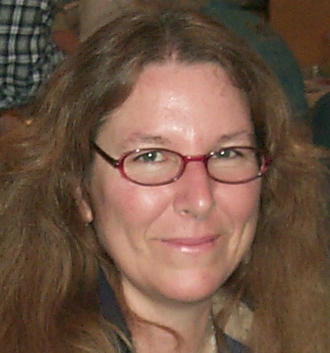

PRESIDENT’S MESSAGE
By: CJ Quitoriano

Hi y'all!
Summer is here, and boy is it a bit toasty!
This month our program is going to be Crystal Growth by Jonathan. So come and learn!
There has been some progress on the club house. Jim, Jerry and Ray are brainstorming and are going to have a plan ready to vote on this meeting.
Thanks to the team!
The fair is coming up fast, I will have sign up sheets for shifts at the meeting.
Please sign up for as many shifts as you can. You get free entry to the fair, and you get to meet all kinds of interesting people!
There will also be sign ups for demonstrators for the fair. We will have the Genie set up at one table, and then different demos on a second table. If you have anything that you would like to demonstrate, either for a shift, a day, or multiple shifts/days, please sign up!
We have had bead stringing, sphere making, rock painting, and lampwork bead demos in the past, and would love to add your skill to our repertoire!
Let's try and fill cases this year with our club member's awesome work! If you can, wire wrap, bead, or whatever, there is a place for you at the fair! In July, Steve is going to show you how to display for the fair, so have something in mind that you want to display!
We will need more rocks for rock bags to sell at the fair. So if you have a bunch of rocks that you've collected on field trips, bring them to the meeting. We will be planning a bag stuffing date soon.
We will not have a meeting in August, but we will have our potluck, we will have sign ups for that at our July meeting.
Refreshments for June are Lorraine Barnard and the Walbloms for snacks, and Elaine C for drinks. Pleas let us know in advance if you will make it or not.
Stay cool and I'll see you at on Tuesday!
CJ

THE CLUB HAS A NEW E-MAIL

avgemclub@gmail.com

Calendar of Events!
6/23 General Meeting
6/28 Cerro Gordo Field Trip
7/21 Board Meeting
7/28 General Meeting
8/15 Club Picnic 10a.m. - ?
8/20 Fair Booth set-up 5p.m.
8/21- 8/30 A V Fair Club Booth
8/31 Fair Booth take down 9a.m.

********************************
June Program
By: Jonathan Numer
CRYSTAL GROWTH
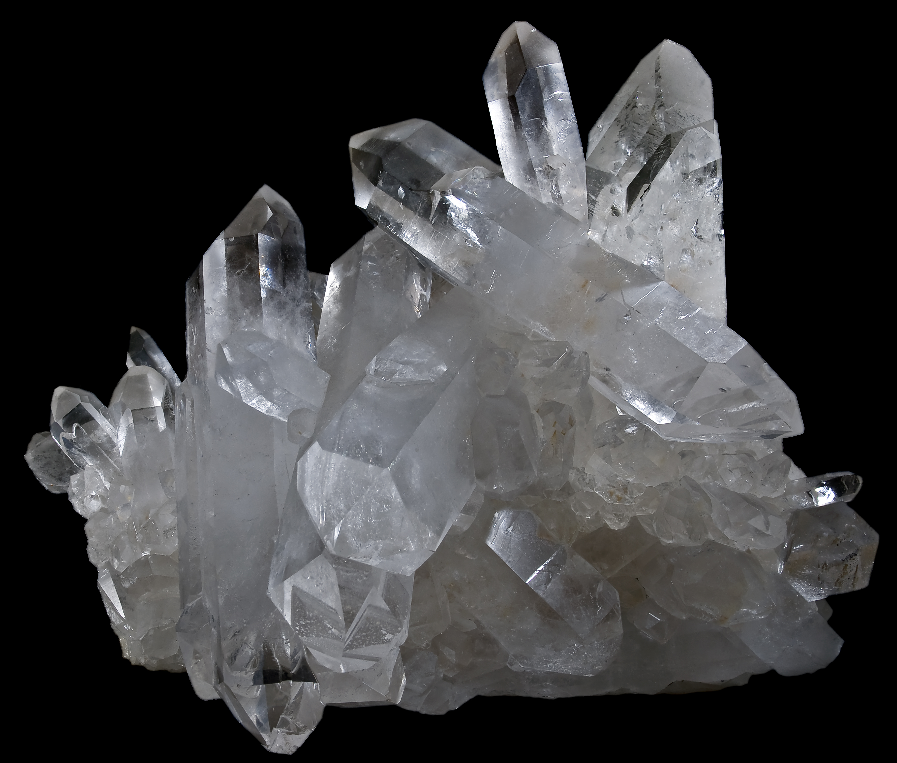
********************************
SPECIAL KIDS ACTIVITY FOR JUNIOR ROCKHOUNDS

June Refreshments


Snacks: Lorrain Barnard
David & Susan Walblom
Drinks: Elaine Cologna

NEEDED SMALL ROCKS FOR ROCK BAGS!!!
(We need a lot of rocks!)

Articles
Page 1 ……….President’s message
Page 1………..Calendar
Page 2………..Program-Crystal Growth
Page 2………..Refreshments
Page 2…………Rocks for bags needed
Page 3………..FIELD TRIPS
Page 4………..Birthdays & Anniversaries
Page 4………..Web site up dates
Page 4 & 5….General Meeting Minutes
Page 5 & 6….Board Meeting Minutes
Page 6……….CFMS Local Show Listing
Page 7………..AV G&M Board & Directors

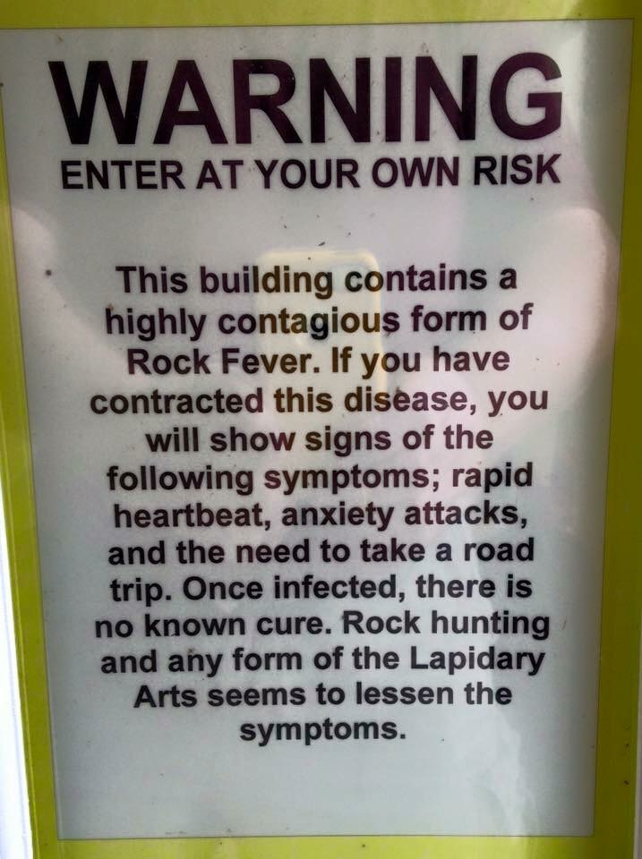

Credit: Thom Ericson via the Rockhound Connection FB page.

WE ARE LOOKING FOR DEMONSTRATORS FOR THE FAIR!!!

Our next field trip will be to: Cerro Gordo
By: Paul Hobbs
Sunday 6/28/15 as is hosted by the Lone Pine Club. This trip affords the opportunity to collect minerals on the dumps of a privately owned silver ghost town/mine. The history is interesting and the scenery is beautiful.

Date 6/28
Time 8:00 am
Meet at Lee's Frontier Chevron in Lone Pine.
1900 S Main St
Lone Pine, CA 93545

Fee- 5.00 + 5 pieces of fire wood + 5 gallons of drinking water PER PERSON. (More is always appreciated by the caretaker at Cerro Gordo).

Vehicles: 4wd High-clearance vehicles are recommended, with low gearing for the last 15 miles of the trip, which takes about 45 minutes from Lone Pine. This road is steep but well graded dirt road (9 miles with 5000 elevation gain). Car pooling can be arranged at Chevron station.

Tools to bring: small hand rake (three prong garden tool) for scraping through the tailings, spray bottle, shovel, rock pick or hammer, collecting bag or bucket, wrap for your specimens, sturdy boots, sunscreen, hat, and plenty of drinking water.

Bring water and lunch. There is no place to buy food once you leave the meeting place. Cerro Gordo is at an elevation of 8,300ft. It'll be several degrees cooler than the valley floor. The temperature can either be hot or cold so plan accordingly.

You need to climb up a steep hill, at a high elevation, to get to the collecting. It isn't a far walk, but all the collecting is done on steep hills. It is a moderately difficult trip.

Historic California has some great historical info on the town @ http://www.explorehistoricalif.com/cerro_history.html. There is also the Friends of Cerro Gordo Facebook page that has great info. You can find a list of the many mineral found at Cerro Gordo on
MinDat - http://www.mindat.org/loc-257101.html

JULY FIELD TRIP
Although the Antelope Valley affords some great rockhounding nearby, the summer is simply too hot to do desert collecting. Therefore our July field trip will be BEACH collecting at Refugio State beach Saturday 7/18/15 for petrified bone and agate. The rocks should be turned over quite a bit from the oil spill clean up. It is about a 3 hr drive from Palmdale. We can hit some other beaches nearby as well. Day use fees are $10.00. We will meet at the Park Entrance at 10:00 a.m.
Location/Directions
Refugio SB is located 20 miles West of Santa Barbara on Highway 101 at Refugio Road.
Address
Refugio SB
10 Refugio Beach Road
Goleta CA 93117
More info on Refugio State Beach can be found at
http://www.parks.ca.gov/?page_id=603.
Mark your calendars and plan to spend at day at the beach.
Paul Hobbs
Field Trip Chair

JUNE
HAPPY BIRTHDAY
& ANNIVERSARY

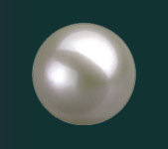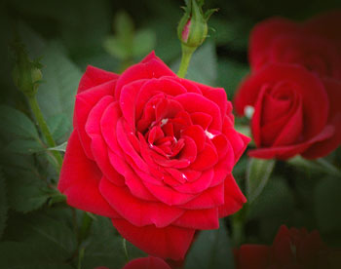
Pearl Rose

Birthdays
6/2 Sheila Berger
6/3 Lucas Karnes
6/8 Stella Janicki
6/10 Rhonda Hedgecock
6/11 Paul Hobbs
6/14 Bonnie Forstner
6/16 Carey Beasley

Anniversaries
6/23 Betty & Steve Witick
6/26 Carey & Derek Beasley

CLUB WEBSITE
www.avgem.weebly.com

Hey all! If anyone took photos you're willing to share, from either the Spring Show or the recent field trips, please send my way. I'd love to have
some more to select from for the website. Our email is in the newsletter (last page of the hardcopy, not the online version). And here is the club's website address if you need it: http://avgem.weebly.com. Thanks! Rhonda

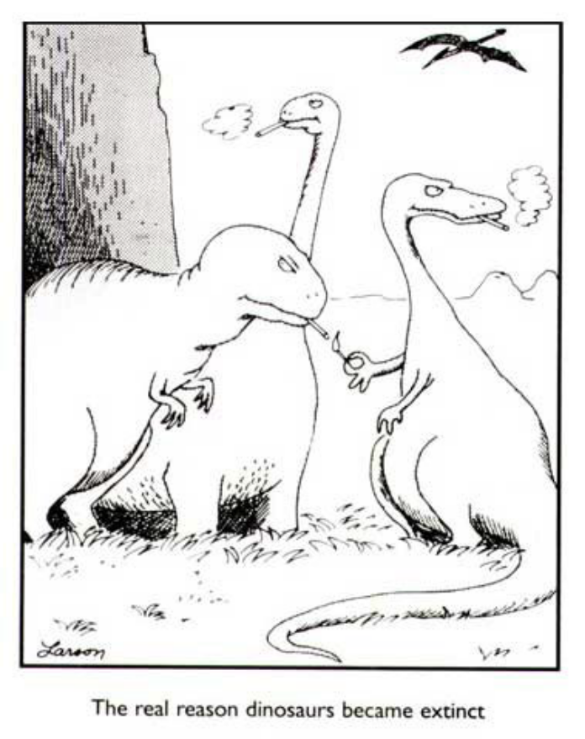

Antelope Valley Gem & Mineral
May 2015 General Meeting Minutes

The meeting was called to order at 7:15
Flag salute
Those present - Members 26, Guests 12.
Marcia made a motion to accept the minutes as printed. It was seconded by Steve.
TREASURERʼS REPORT - The reason for more than the usual being given out last year was
explained by Susan.
DOOR PRIZES - Three were given out.
BADGE DRAWING - Careyʼs name was drawn but she didnʼt have her badge.
THE FAIR - books were explained by Susan and passed out to those who wish to display. The date to set up is Aug. 20th.
PROGRAMS - not available tonight
FIELD TRIP - Paul told us the next one will be to Cerro Gordo on the 28th. We will meet in Lone Pine to car pool if needed. Cost to get in is $5, 5 gallons of water and 5 pieces of firewood. There are steep hills to get to the collecting site and high elevation. 4x4 is recommended. Paul will bring in a sample of the rocks that can be found to the next meeting.
BULLETIN - It was sent out. Please keep sending in articles.
ROCKHOUND of the Month was explained to new members and guests. Those who brought things in, shared what it was and where they found it. Voting will be during the break.
BREAK
MEMBERSHIP - Elaine said we have five new members.
REFRESHMENTS - list for next month was unavailable.
PROGRAMS - next moth will be on crystal growth.
PUBLICITY - Ruth thanked Susan and Marcia for all their help with the SHOW ads. She also
reminded everyone that we are on Facebook.
ALAA - Ruth is working on getting a comment to make the BLM aware of the areas we want to stay open to us.
SCHOLARSHIPS - Mary shared the guidelines she came up with. Susan made a motion to accept them with the few changes that were discussed. It was seconded by Elaine. Rhonda will post the application on our web site.
JR. ROCKHOUNDS - Christine talked to the parents about having a display at the FAIR. Orange vests need to be made for them to display their badges. More information will be shared at the next meeting.
THE CLUBHOUSE RENOVATION COMMITTEE will be meeting tomorrow to put up the new counters in the back room.
FEDERATION NEWS - The Show is in Lodi on June 12 - 14th.
ROCKHOUND OF THE MONTH was won by CJ for her bead on a key.
50/50 of $34.00 was won by Elaine.
There will be a Club B-B-Q at the CLUBHOUSE on August 15th. More information to follow.
Meeting was adjourned at 8:38

Antelope Valley Gem & Mineral
June, 2015 Board Meeting Minutes

Meeting was called to order at 7:15.
Those present - Ray & CJ, Jerry & Lorelei, David & Susan, Jim & Marcia, Mary,
Gordon and Ruth.
Minutes were read from last monthʼs meeting. Gordon made a motion to accept the
minutes as read. It was seconded by Jim. All in favor.
TREASURERʼS report was read by Susan.
BULLETIN - Stuff needs to be sent in TONIGHT.
FEDERATION NEWS - Ventura will host the 2017 CFMS/AFMS show. Lodi show went well.
MEMBERSHIP - Not here. A few members were added at the last general meeting.
REFRESHMENTS this month - Lorraine, Elaine, David & Susan.
FIELD TRIP - Cerro Gordo on the 28th of June.
PROGRAMS - Jonathan will talk on Crystal Growth. Christine will have something for
the Jr. Rockhounds to do.
PUBLICITY - quiet. Need to let people know that we at not having a meting in August.
They can come see us at the Fair.
Web Site - The show dates need to be taken off and replaced with 2016 TBA
ALAA - Ruth attended a talk at the Lodi Show. Found out that we, rockhounds, have a
loud voice and are being heard and listened to.
AV FAIR - Rocks are needed to fill more rock bags. We need to ask people for
donations. When you go on field trips, please bring back extra for the club.
Fair dates are Aug. 21-30th. More people are needed to demo. A sign-up sheet will be
passed around at the next two meetings. Set up will be on the 20th at 5:00 p.m. and
take down will be on the 31st at 9:00 a.m.
OLD BUSINESS - It was decided that this yearʼs Christmas dinner will again be held at
the Habachi Grill with a raffle and gift exchange. Non-members need to pay.
*We donʼt have a bill from the High School yet for use during the Rock Show. CJ will
ask Ed to contact them. We also need to set a date for the 2016 Show.
* Ruth wanted to know if the building committee could come up with a list of some
things that need to be done in the Club House. A date was set by them to start a list
to be taken to the membership for approval.
SCHOLARSHIPS - We have only received one so far. Mary will contact the local
colleges tomorrow to se if more can be acquired.
NEW BUSINESS - The Jet Hawks want to know if we want to do a fundraiser. CJ sent
them a message asking what all is involved.
*Nominations are needed for next years officers. CJ will appoint a chairpersosn for this
at the Sept. meeting. A list of those who accept a nomination will be printed in the Oct.
bulletin.
The July board meeting will be on the 21st.
There will be no general meeting in August because of the Fair.
Gordon made a motion to adjourn the meeting. It was seconded by Jim.
Meeting was adjourned at 8:59.

ARTICLES FOR YOUR NEWSLETTER ARE DUE TO THE EDITOR BY THE 15th OF EACH MONTH!

2015 Local CFMS Show Listings

August 7 – 9: NIPOMO, CA
Orcutt Mineral Society
Nipomo High School
525 Thompson Avenue
Hours: Fri. & Sat. 10-5; Sun. 10-4
Wes Lingerfelt (805) 929-3788
http://omsinc.org

August 22 & 23: SAN FRANCISCO, CA
San Francisco Gem & Mineral Society
San Francisco County Fair Building
9th Avenue & Lincoln Way
Hours: Sat. 10am-5pm; Sun. 10am-6pm
Ellen Nott
ellen_nott@yahoo.com
www.sfgemshow.org

August 29 & 30: CONCORD, CA
Contra Costa Mineral & Gem Society
Centre Concord
5298 Clayton Rd. (near Ygnacio Rd.)
Hours: 10 a.m. – 5 p.m. Daily
Harry Nichandros (925) 289-0454
Show-c@ccmgs.org
http://www.ccmgs.org/gem_show/

Sept. 19 & 20: REDWOOD CITY, CA
Sequoia Gem & Mineral Society
Harvest of Gems & Mineral Show
1400 Roosevelt Avenue
Hours: 10:00 a.m. – 5:00 p.m. Daily
Carol Corden
cordencarol@yahoo.com
www.sequoiagemandmineralsociety.org

September 19 & 20: CHICO, CA
Feather River Lapidary & Mineral Society
Silver Dollar Fairgrounds
2357 Fair Street
Hours: 9:30 a.m. – 5 p.m. Daily
John Scott (530) 343-3491
Cell (530) 321-6331
jweazel@sbcglobal.net featherriverrocks.org

September 26 & 27: MONTEREY, CA
Carmel Valley Gem & Mineral Society
Monterey Fairgrounds
2004 Fairgrounds Road
Hours: Sat. 10-6; Sun. 10-5
Janis Rovetti (831) 372-1311
janis12@sbcglobal.net
www.cvgms.com

September 26 & 27: LODI, CA
Stockton Lapidary and Mineral Society
Lodi Grape Festival Grounds
413 East Lockeford Street
Hours: 10am – 5pm Daily
Jerold Kyle (209) 368-9411
jeroldkyle@yahoo.com
stocktonlapidary.com

September 26 & 27: SANTA ROSA, CA
Santa Rosa Mineral & Gem Society
Wells Fargo Center for the Art
50 Mark West Springs Road
Hours: Sat. 10-6; Sun. 10-5
Jolene (707) 528-7615
Jolene@SRMGS.org
www.SRMGS.org

September 26 & 27: DOWNEY, CA
Delvers Gem & Mineral Society
Elks Lodge
11233 Woodruff Avenue
Hours: Sat. 9-5; Sun. 9-4
Dale Hardwood (310) 217-0551
nancybird@verizon.net

Sept. 30 – Oct. 4: JOSHUA TREE, CA
Hi-Desert Rockhounds
Sportsman’s Club of Joshua Tree
6225 Sunburst Street
Hours: 9a.m. – 6p.m. Daily
Judy Thompson (760) 902-5340
rogerthompson@mac.com



See you at the MEETING!



