_______________ _____ ________ _____________ January 2015

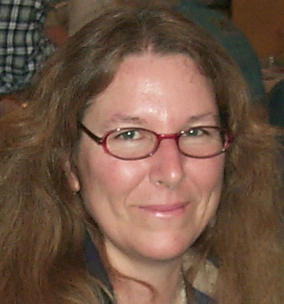

PRESIDENT’S MESSAGE
By: CJ Quitoriano

Merry Christmas everyone!
I hope that everyone had a wonderful Thanksgiving and didn't eat too much!
Don't forget our holiday party on Tuesday. We will be at the Hibachi Grill at the Palmdale Mall, 6:30-9:00. The club is paying for all current members, so make sure you bring your dues! Also bring a wrapped gift, valued between $15-$20, for the gift exchange, and raffle money!
Lorelei and I went shopping and purchased what we think, are some pretty nice items for prizes. We are also taking donations, so if you have something you would like to donate, please feel free to bring it to the party and give it to either Lorelei or me.
This is going to substitute for our regular meeting, so don't show up on the fourth Tuesday this month! Ruth, don't put it in the newspaper either....
Board members, we are having our board meeting the following Tuesday at Lorelei and Jerry Paland's house. If you need the address, call the number in the back of the newsletter and any of us can tell you.
New board members, Congratulations!!! Please come to the meeting! Directors as well, and if you are a new member and want to check out what we do at these meetings, please feel free to join us! Chair people are welcome as well, and if you want to come, please do, it can help you to understand your position much better.
I hope to see you all there on Tuesday!
CJ

Calendar of Events!
11/25 General Meeting
12/9 CLUB CHRISTMAS PARTY
12/16 Board Meeting
1/13 Board Meeting
1/27 General Meeting

Tuesday
December 9th
^{6:30p.m.-9:00p.m.}
Club Christmas Party!!!
Hibachi Grill Buffet
1215 West Rancho Vista Blvd.
In the Mall parking lot (Ave. O-8)
Gift Exchange ($15-$20)
Raffle with Great Prizes
(Bring money for tickets)

Articles
Page 1 ……….President’s message
Page 1………..Calendar of Events
Page 1………..Christmas Party
Page 2………..2015 Board & Directors
Page 2………..Dues are due!
Page 3………..Birthdays & Anniversaries
Page 3………..Website
Page 3…….….Meeting minutes
Page 4………..Save Lonely Butte
Page 4………..CFMS News & Shows
Page 5………..AV G&M Board & Directors

2015
Board & Directors
President – C.J. Quitoriano
Vice President – Marcia Betts
Secretary-Lorelei Paland
Treasurer-Susan Chaisson-Walblom
Club Directors
Jerry Paland
Ray Quitoriano
David Walblom
Jim Betts
Gordon Butler

Rock Nativity
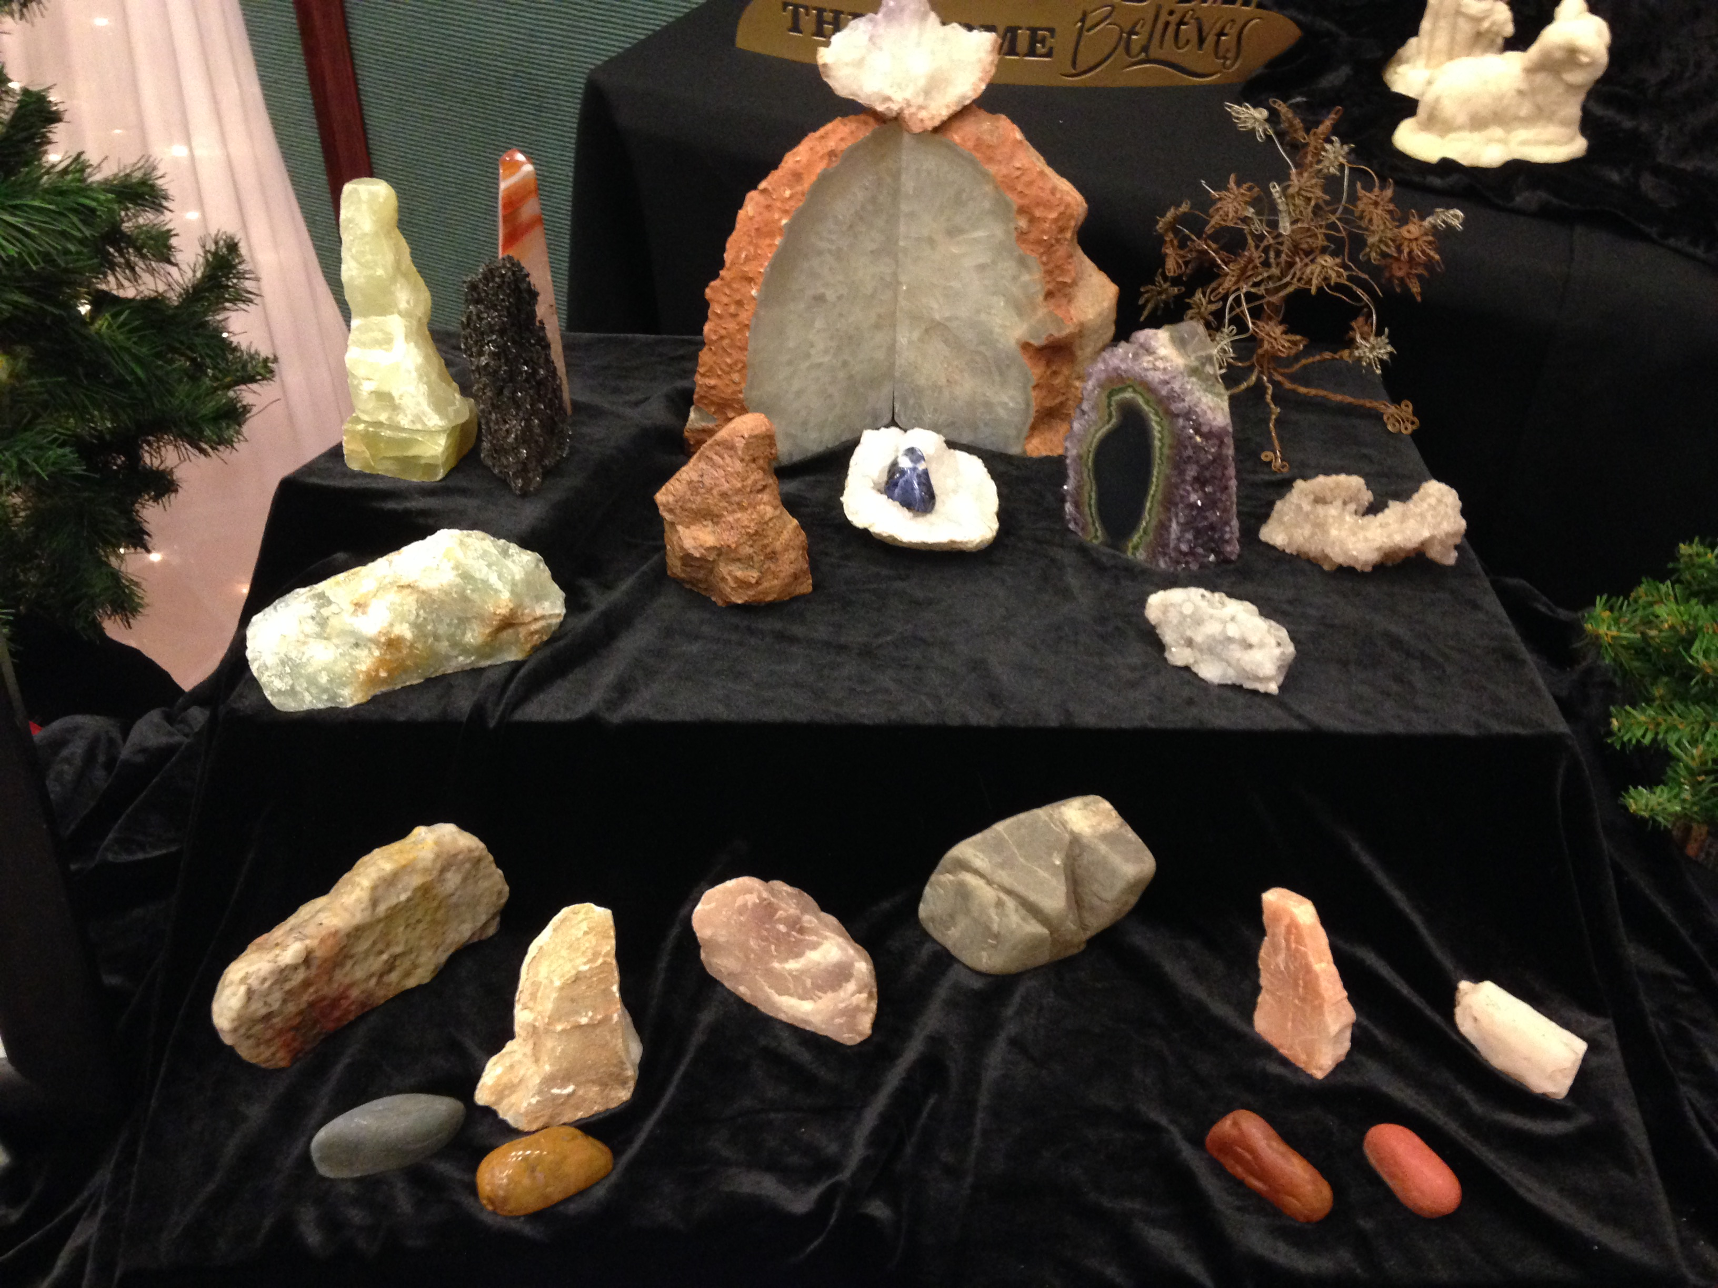

picture by: Gordon Butler
DUES ARE DUE!!!
Please pay your dues at the Christmas party!
Or, mail to:
Susan Chaisson-Walblom
42122-52nd Street West Quartz Hill, Ca 93536
Adults-$15 & Juniors (8-17)-$5




HAPPY
BIRTHDAY & ANNIVERSARY

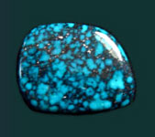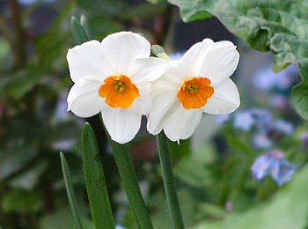
Turquoise Narcissus

DECEMBER
12/15 Lorelei Paland
12/18 Steve Wittick
12/19 David Haven
12/21 Holly Thorn
12/29 Lorraine Barnard

Anniversaries

12/21 Jerry & Lorelei Paland

CLUB WEBSITE
www.avgem.weebly.com
You can check out the club’s website at: http://avgem.weebly.com. As I am able to get updated information, I update the website as well. And just a reminder - I welcome any help with photos from the general meetings and events, award winning items and winners, and field trips to help keep the website current. Rhonda

SLABS
The Club needs your help! We need any extra slabs you have laying around. The slabs will be used to make critters for the spinning wheel at the Poppy Festival-Our Show-Fair booth!
THANK YOU! THANK YOU! THANK YOU!

*REMEMBER *
ARTICLES FOR YOUR NEWSLETTER ARE DUE TO THE EDITOR BY THE 3rd SATURDAY OF EACH MONTH!!!

AV Gem & Mineral Club
2014 Board Meeting Minutes
November Minutes not available at this time

Antelope Valley Gem & Mineral
2014 General Meeting Minutes
November Minutes not available at this time



Save Gem Hill & Lonely Butte

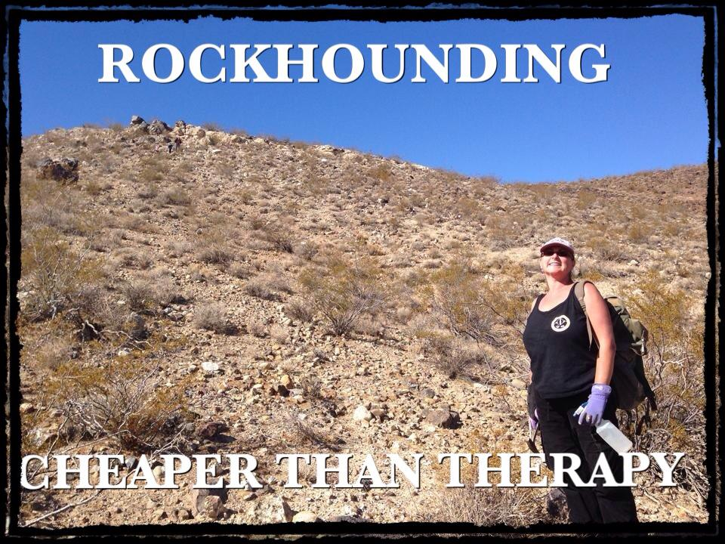
YOU CAN HELP!!
FOLLOWING IS A SUMMARY YOU CAN COPY AND EMAIL OR PRINT FOR DISTRIBUTION TO YOUR CLUBS & FRIENDS. Print it as a flyer and take it to any shows you may be attending!
Rockhounds are in danger of losing two well-known local collecting spots to solar and/or wind farm development. Both Lonely Butte aka Brown Butte and Gem Hill lie directly in the Development Focus area of the DRECP. Both of these spots are in the Gem Trails of Southern California books and have been used by Rockhounds for decades.
The Desert Renewable Energy Conservation Plan (DRECP), a major component of California's renewable energy planning effort. It is designed to streamline and fast track the permitting process for huge solar and wind development in the California Deserts.
The required meetings for comments are currently in progress. Please attend if you can and make it known we want to be able to continue to access these areas and keep them open for future generations. For meeting locations go to http://drecp.org.
Public comments can also be submitted in writing through January 9, 2015. Go to the website: http://drecp.org for information on how to comment, maps and much more.
A FB page - SAVE GEM HILL & LONELY BUTTE has been created to unit Rockhounds in this endeavor
Specific information on these two location you may want to use in your comment follow:
BROWN BUTTE AKA LONELY BUTTE:
Township 10 N
Range 11 W
Sections 2, 3, 10, & 11.
Note section 2 is all BLM and Section 10 is mostly BLM land.
GPS- 34.976746 Longitude
-118.024271 Longitude
GEM HILL:
GPS at one area of collection:
34.926220 Latitude
-118.22122 Longitude
Township 10 N
Range 13 W
Sections 26, 27, 34 & 35

2014 Local CFMS Show Listings

Quartzsite Arizona
Tyson Wells January 2-February 8
Pow Wow January 21-25

January 17&18: EXETER, CA
Tule Gem and Mineral Society
Exeter Veteran's Memorial Building
324 N. Kaweah, Hwy 65
Hours: Sat. 10-5, Sun. 10-4
Bill Bingaman (559) 741-6381
Bandgbing@aol.com
www.tulegem.com

February 13 – 22: INDIO, CA
San Gorgonio Mineral & Gem Society
Riverside Co. Fair & Date Festival
82-503 Hwy. 111
Hours: 10 a.m. – 10 p.m. Daily
Bert Grisham (951) 849-1674
bert67@verizon.net

February 27 – March 8: IMPERIAL, CA
Imperial Valley Gem & Mineral Society
Imperial Valley Expo
200 East 2nd Street
Weekends noon-10pm; Weekdays 4pm-10pm
John Pyle, Jr. (760) 562-3453
jcwus@sbcglobal.net
IVGMS.org

