_______________ _____ ________ _____________ December 2015

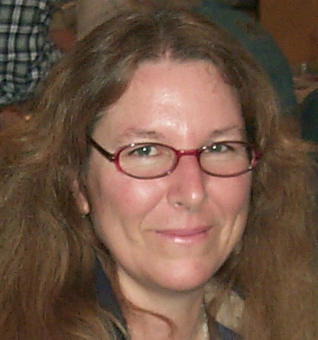

PRESIDENT’S MESSAGE
By: CJ Quitoriano

Happy Holidays!
I hope this newsletter finds you all well?
This will be my last newsletter article as your President!
I'm excited!!
I want to thank Marcia and Ruth for stepping up and taking the President and Vice President nominations this year! They will make a great team!
Elections will be held during the next meeting and don't forget that your dues are due! Please see Susan to make your payments!
Thank you to Jerry, Jim, and Ray for coming over and fixing the trailer floor! We should be able to use the equipment room VERY soon!
On that note, I would like to ask for volunteers to step up and help these guys out with getting the trailer fixed up. It looks to be a very wet winter, and the trailer needs some weather proofing.
At this time, we do not have a scheduled "class", but we do have the equipment for member's use.
We have a 24" saw at Jules' house, you can contact him if you need to do some slabbing.
We have two Genie's and a Titan for cabbing, but you need to have some experience with these machines in order to borrow them. There are some care and cleaning instructions that everyone must follow in order to keep the machines in good working order. If you are interested in borrowing one of these machines, please let me know and we will work with you.
(Continued on page 3)

DUES
ARE DUE!!!
Please pay your dues at the November General Meeting! or
Mail by December 1st to: Susan Chaisson-Walblom
42122-52nd Street West Quartz Hill, Ca 93536
Adults-$15 & Juniors (8-17)-$5

NOMINATION
&
ELECTION TIME

The following slate of officers has been recommended by the nominating committee. However, nomination will be accepted from the floor at the November meeting prior to elections.
President - Marcia Betz
Vice President - Ruth Hidalgo
Secretary - Lorelei Paland
Treasurer -Susan Chaisson-Walblom
Director - Gordon Butler
Director - Jim Betts
Director - Jerry Paland
Director - David Walblom
Director - CJ Quitoriano
Calendar of Events!
11/24 General Meeting
12/8 CLUB Christmas Party (6p.m.)
1/1/16 Quartzsite Shows begin
1/12 Board Meeting
1/26 General Meeting
4/23 & 24 CLUB SHOW

November Program

Randy Banis will be our guest speaker at November's General Meeting.

Mr. Banis serves as an advisor to the BLM on the Desert Advisory Council representing the Public at Large. He has worked on BOTH the Monument bills that will affect some of the best rock collecting sites in Southern California, the Cady and Lavic collecting areas, worked on the WEMO travel management plan which will affect the roads we use to get to collecting spots and completed an extensive analysis of the DRECP for Rockhounds. As a result, Rockhounds were very well represented in the DRECP comments. If this all sounds Greek to you, you need to be at this meeting. If you have tried to make sense of any of these plans, but found yourself overwhelmed or lacking the time it takes to navigate the massive documents, this meeting will provide accurate information and tools that will help you. If you enjoy getting out and collecting rocks, this meeting has lots for you. Don't miss it!

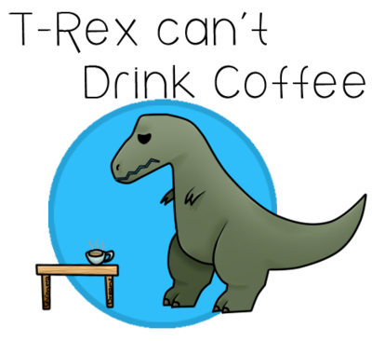

November Refreshments

Snacks: Lorelei Paland
Snacks: Mary Black
Drinks: Carol Trees



DECEMBER MEETING CHRISTMAS PARTY
DECEMBER 8th
6:00 p.m.

Medrano’s Mexican Restaurant
44276-10th Street West, Lancaster

Club Members $5
Junior Members (under 10) FREE
Guest Adults $20
Guest (under 10) $10

(President’s message continued)
The December meeting/Christmas party will be held on December 8th, at 6:00, located at Medranos Mexican Restaurant, located at
44276 10th St. in Lancaster. The dinner will be buffet style, vegetarian dishes are available upon request.
It will cost each adult $5, which includes the food, drink, and tip, children under 10 eat free, if you are bringing a guest the guest will be charged the full $20 price for the buffet, non-member children under 10 are $10.
There is a full bar in the banquet room, you pay for your own alcoholic drinks.
We need a head count, so I am sending out an email to every member as well as requesting a call, text, or email from you here, if you do not get the email.
Please let me know if you are coming or not, how many in your party, and if they are under 10 years old.
Lorelei and I had a great time shopping for the Christmas party raffle last week. I think we picked out some pretty awesome things that everyone is going to want to win! Donations are gratefully accepted as well, so bring them to the next meeting or the party!
If you are new to the club, we have an annual party in early December to celebrate the holidays.
Last year we started a raffle fund from the money gathered through 50/50 drawings and we bought raffle prizes with that money. This year, we added the money from the ticket sales from last year's party, and added the 50/50 drawing money from this year.
This year our raffle funds were over $400!! So, the more you spend on the 50/50 and the raffle this year, will roll over into next years raffle fund! Cool, yeah? So keep buying those tickets! I know I will!
Raffle tickets will be sold during the next meeting and during the party, $1 each, or 6 for $5, so bring your cash!
Over the last four years as this club's President, I have had the honor of working with some fabulously talented, awesome people! I can't thank them all here, because I know I will forget someone, and that would suck.
But I do want to thank each and every one of you who have helped our club grow and prosper within the last four years. We have almost doubled in membership, we have our workshop, which I hope to get going very soon, and everything we do, Fair, Show, Poppy Festival, have all been successful and profitable for our club!
Thank you for all of your help, I hope that you will continue to help me, as those are duties that I will be retaining for the next year!
I feel like I'm accepting an Academy Award or something….
But, I can't finish this letter without thanking the most important person of all, Ray. Without him I don't know what I would do. He has been my muscle, my sounding board, my whipping boy, and most of all, the biggest help and biggest supporter of all I have done and do. Thank you Ray!! Love you!!
Okay, now that that is over...
Please come to the next meeting and pay for your party meal, we need a head count ASAP so we know how much we will have to pay. See me or Lorelei to make your payment so we can mark you down!
We need a minimum of 30 people, so come one, come all! It's going to be a GREAT time!
See you all at the meeting!! CJ


Articles
Page 1 & 3 …President’s message
Page 1………..Dues are Due!
Page 1………..2016 Nominations
Page 2………..Calendar
Page 2………..Program
Page 2………..Refreshments
Page 2…….….Club Christmas Party
Page 3………..President’s message
Page 4………..Field Trips
Page 4………..Club Website/E-mail
Page 5………..Birthdays & Anniversaries
Page 6 & 7….General Meeting Minutes
Page 7 & 8….Board Meeting Minutes
Page 8………..CFMS Local Show Listing
Page 9………..AV G&M Board & Directors


THE CLUB E-MAIL
avgemclub@gmail.com
CLUB WEBSITE
www.avgem.weebly.com
I am always in need of photos from meetings, field trips and events to consider for use on the website. If you have posted any on Facebook and are willing for me to use them on the club's website, let me know! (As a reminder, here is the club's website address: http://avgem.weebly.com. My contact info is on the last page of the club bulletin - your copy, not online version.) Thanks! Rhonda

Field Trips - by Paul Hobbs
The Field Trip to the Omnya Mine was 11/8. After a short but very educational slide show presentation on the mine and the minerals found there, everyone had a good idea of what to look for. We were taken on a tour of the mine and then to different dump areas to collect various minerals. Attendees were allowed to collect as much as they could carry. A very special THANK YOU to retired mine geologist Howard Brown for leading this trip on his personal time.
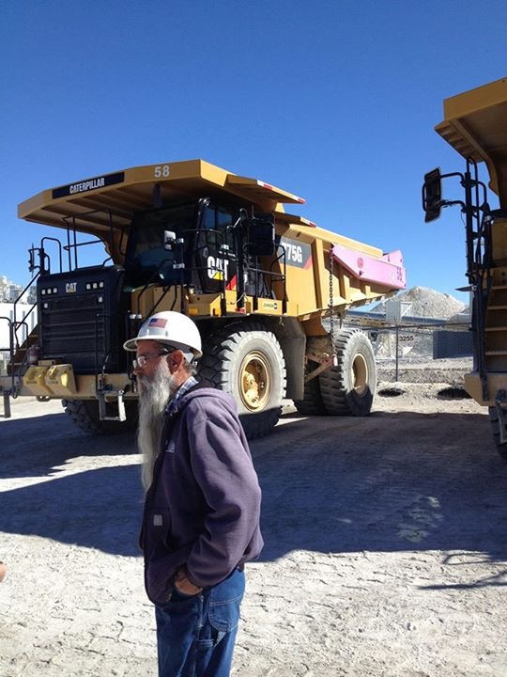
DECEMBER FIELD TRIP
.
Since many of us don't want to miss the Barstow show and December is such a busy month for everyone, our next field trip will be 12/5 to the Calico area for agate, Jasper and petrified wood. We will be meeting at Peggy Sues Diner off the 15 freeway at 8:00 AM. We should have plenty of time to get in plenty of collecting and still make it to show in Barstow.
BIRTHDAY & ANNIVERSARY

November Birthdays

Topaz Chrysanthemum
11/6 Danny Watts
11/7 Lana Haven
11/7 Sarah Janicki
11/12 Jerry Paland
11/12 Olivia Miseroy
11/13 Mary Black
11/29 Ellen Niduvitch
11/30 Elaine Cologna

Anniversaries

11/21 Danny & Vivian Watts

PLEASE SEE SUSAN TO CONFIRM THAT YOUR BIRTHDAYS & ANNIVERSARIES OUR ON OUR CLUB’S LIST. Thank you!






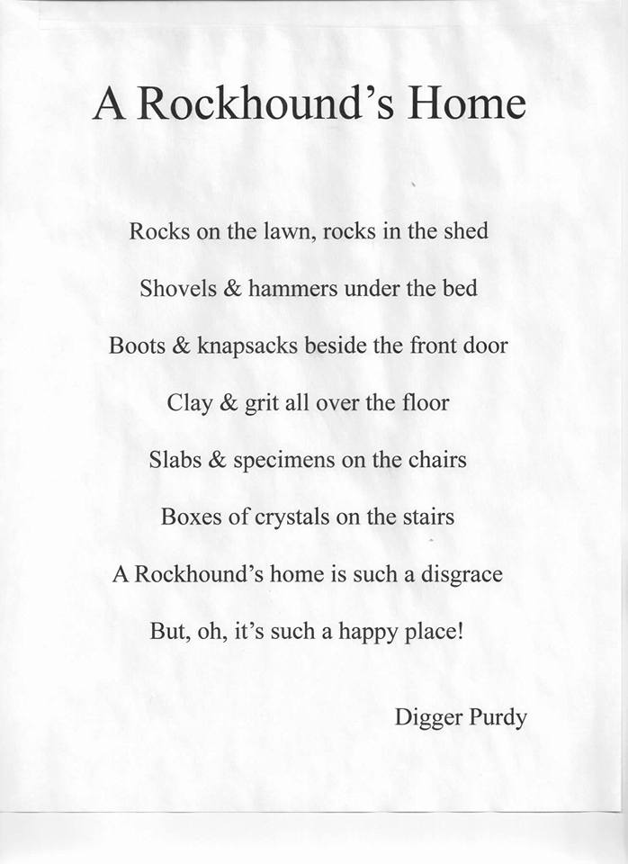

ARTICLES FOR YOUR NEWSLETTER ARE DUE TO THE EDITOR BY THE 15th OF EACH MONTH

Antelope Valley Gem & Mineral
10-27-15 General Meeting Minutes

C. J. Quitoriano called the meeting to order at 7:17 PM 10/27/2015. Ray Quitoriano displayed the American Flag and C.J. led the Pledge of Allegiance. The Hostess Report was given by Ray as 25 members being present and 2 guests. C.J. asked the guests to introduce themselves to the general assembly. The first guest introduced himself as Jim McVicker and said he had learned of us through the Internet. The second guest introduced himself as Rodger and said he had learned of us at the AV Fair this year.
The minutes of the last general meeting was moved by Marcia Betz to be accepted as printed in our monthly Newsletter, and the motion was seconded by Ray.
In the Treasury Report by Susan Walblom she stated we had paid out all of our Scholarships for this year. Our current general account balance is $10,000 and our savings account balance is $15,000. Sue also gave the Newsletter report. Members not getting the Newsletter via email were Steve Wittick and Jonathan Numer. Susan passed around a copy of her current membership information list asking those present to verify and update emails, birthdays, and any other missing or erroneous information on the back. She said she will make an updated membership information list and bring some copies to the next meeting. She requested articles for the Newsletter from the membership and indicated Ruth Hidalgo has supplied an article in the current Newsletter. Sue brought the current copy of the American Federation of Gem and Mineral’s Newsletter for any interested members to read.
C.J. awarded Danny Watts the Triangle and Bar pin for being Vice President last year.
The door prizes, organized by Jules Ficke, were in three paper bags and were drawn for. The first winner was Mary Black whose bag choice turned out to be a book on crystals. The second winner was Danny Watts whose choice turned out to be a belt buckle with a large, agate, oval cabochon in its center. The last prize was won by Ellen Niduvitch and turned out to be a small stone soap dish made with imbedded Moroccan sea shell fossils.
C.J. drew Ellen’s name from the Badge Drawing jar, and since she had her badge on she was awarded $5.00.
C.J. explained the Rockhound of the Month trophy voting to be done during the break by all those in attendance regardless of membership, and that tickets for a 50/50 drawing would be sold during the break.
Program Chairman Jonathan Numer introduced Chris Astrada., a 3rd year Geology major specializing in Crystals who spoke for about half an hour. Chris showed examples of crystal shapes, discussed different UV lights and demonstrated florescence in Calcite crystals, the imperfections in them creating the various colors.
C.J. announced that she had awarded Danny the Triangle and Bar lapel pin for being VP last year in error. He had been the VP the previous year. Last year the VP had been his wife, Vivian Watts, who was then correctly awarded the Triangle and Bar lapel pin.
C.J. called the break at 8:05, and began selling 50/50 tickets while the members mingled, snacked, and voted on the Rockhound of the Month.
At 8:25 P.M. C.J. called the meeting back to order.
David and Susan Walblom will be attending the American Federation of Gem and Mineral meeting which occurs on the second weekend in November, November 14th this year.
Paul Hobbs, Field Trip Chairman, declared the Trona field trip to be successful and fun filled adventure for all those who attended. He discussed the upcoming Omya Mine field trip that he was able to arrange for through Howard Brown this November 7th. There is an upper limit of 25 people who can attend this field trip so be sure to sign up early. He discussed the types of minerals we may find there, the use of a black light and black garbage bag to see the florescence of samples during daylight, the mine’s safety and clothing requirements, including hard hat, safety goggles, and good protective clothing and shoes (The hard hat will be supplied there if you don’t have your own), the meet up time and place, and vehicle requirements to reach the mine.
In the membership report by Mary Black, she stated we have received badges for our new members, but none of them were present at the meeting.
In the refreshment report by Ray, he didn’t have the names of those who have signed up to bring refreshments to the next general meeting with him, but assured us that, as usual, they will be contacted by phone prior to the meeting to remind them.
Ruth Hidalgo reported about next month’s Desert Area Council meeting where the future use of BLM land will be discussed and she impressed the importance of us making our voices heard. The Off Roaders have a very vocal following, she said, but Rockhounding is not really known of as an activity in rural areas. All the current bills under consideration for the area will reclassify its use. We need to speak out against bills that close land to collecting. Writing emails to those concerned will have a positive effect, she said. Randy Bandit will come to our next general meeting and discuss the various bills and their consequences. C.J. noted that the program director, Jonathan, needed to be informed of Randy’s visit.
Ruth gave the publicity report, stating the only thing currently published in the AV Press is notification of our monthly meetings on the fourth Tuesday of every month.
Jim Betz gave the workshop update. Nothing has been done to the club’s trailer since the last meeting. The current planned project is to strengthen the back room floor with ½ inch plywood, prior to installing linoleum.
Mary also gave the Scholarship report. We are open and waiting for new applicants to apply for our 2016 AVGMC Scholarship Awards.
Our Future Rockhound’s Director, Christine Janicki, along with all of our current Future Rockhounds were not present at the meeting so the Future Rockhound’s Report was tabled until next meeting.
C.J. opened the floor to discussion concerning the timing of our Spring Show. Two dates were discussed in relation to the scheduling of the 2016 Poppy Festival falling on the 16th and 17th of April. The first possibility was holding the Spring Show at its normal time, one week after the Poppy Festival on the 23rd and 24th of April. The second possibility was holding the Spring Show at its scheduled time, the last weekend (Saturday and Sunday) of April on the 30th of April and first of May.
Danny Watts moved to hold the Spring Show on the 23rd and 24th of April and David Walblom seconded the motion. It passed with a unanimous Aye.
Our 2016 Poppy Festival booth was discussed, and although Steve Wittick was not present, it was generally understood that he would most likely be willing to run the booth again as he has so successfully in the past.
C.J. called for nominations to the upcoming Officer and Director elections for the AVGMC. Marcia Betz was nominated for President, Ruth Hildalgo was nominated for Vice President, Susan Walblom was nominated for Treasurer and Lorelei Paland was nominated for Secretary. Nominations for the five Director positions included Jim Betz, Gordon Butler, Jerry Paland, Ray Quitoriano, and C.J. Quitoriano who will automatically become a Director after leaving the Office of Presidency as per Article V, Sec. 1 of our By-Laws. C.J. called a second and third time for nominations from the floor. Commitments to holding Chair Person Positions were extracted from current Chairpersons, Paul Hobbs, David Walblom and Ray Quitoriano, Mary Black during the discussions.
Under Old Business we are still looking for a Christmas Party location. Marcia Betz will check on The Greenhouse Café for their prices. Last year’s location was discussed and members were invited to think of other possibilities.
In New Business Ruth mentioned The Indian Wells club is holding a field trip to their claim on November the seventh and eighth and we are invited to attend.
The 50/50 drawing was held and Ray Quitoriano won $25.00.
The Rock Hound of the Month Award Plaque was won by Troy Ohelo and Maria Quinones.
The meeting was adjourned at 9:03 PM.

Antelope Valley Gem & Mineral
11-10-2015 Board Meeting Minutes

The meting was called to order at 7:15.
Those present - Ray & CJ, David & Susan, Marcia & Jim, Paul & Ruth, Jerry & Lorelei, and
Gordon.
Ray made a motion to accept the minutes as printed. It was seconded by Marcia. All aye.
Treasurerʼs report - copies passed out and discussed moving some money into a money
market account after the first of the year. Ruth is going to check the banks for interest rates.
A budget needs to be made up and presented to the members.
Bulletin - Items for print need to be in ASAP,
Federation Director - The meeting is this weekend. Susan will be attending.
Field Trips - Dec. field trip will be to Calico on the 5th.
Membership - Susan will send out new list. Fees are due in December.
Refreshments for the November meeting will be provided by Lorelei, Mary & Carol.
Programs - Randy Banis will be speaking. He is on the Desert Advisory Council to the BLM.
Spring Show - April 23 7 24 2016. CJ has the contract and will also email a copy of the flyer to
Susan. CJ will continue as Show Chairperson.
Nominees for Officers are as follows - President - Marcia Betz, Vice President - Ruth Hidalgo,
Secretary - Lorelei Paland, Treasurer - Susan Walblom, Directors - CJ Quitoriano, Jerry Paland,
Jim Betz, Gordon Butler and David Walblom.
Building Committee - Will be getting together this Friday to make a list of projects to be done on
the trailer and an estimate of supplies needed.
Christmas Party - Will be at Madranoʼs on Dec. 8th at 6:00. Lorelei will check on the price for
children. Memberʼs cost will be $5 and $20 for non-members. Sign up and pay at the Nov.
meeting. Raffle tickets will be sold for the Christmas prizes and there will be NO white elephant
gift exchange.
Gordon made a motion to adjourn the meeting. It was seconded by Jim.
The meeting was adjourned at 8:30

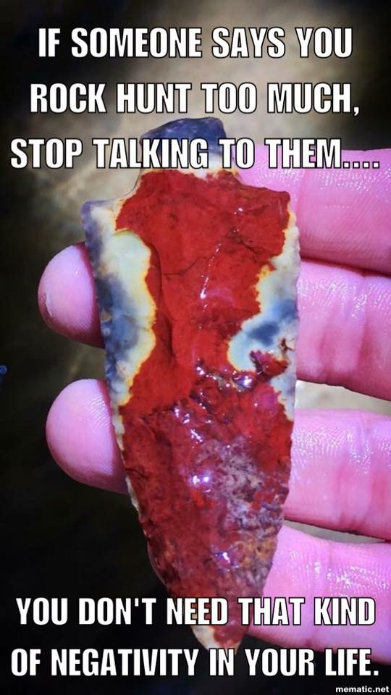


2015 Local CFMS Show Listings

November 21 & 22: APPLE VALLEY, CA
Victor Valley Gem & Miner Club
Victor Valley Museum
11872 Apple Valley Rd.
Hours: Sat. 9-5; Sun. 9-4
Ed Skidmore (760) 243-2330
vp-shows@vvgmc.org
http://www.vvgmc.org/gem-show

December 5 & 6: BARSTOW, CA
MDGMS
Cora Harper Community Center
841 S. Barstow Road
Hours: 10a.m. – 5p.m.
Danny Watts (760) 373-1309
dvwatts@msn.com
www.mdgms.net

December 5 & 6: LAKESIDE, CA
El Cajon Valley Gem & Mineral Society
Lakeside Rodeo Grounds
12584 Mapleview Road
Hours: Sat. 9-5; Sun. 9-4
Mary Ness (619) 449-0759
ecvgms@gmail.com
www.ecvgms.org

December 5 & 6: BARSTOW, CA
MDGMS
Cora Harper Community Center
841 S. Barstow Road
Hours: 10a.m. – 5p.m.
Danny Watts (760) 373-1309
dvwatts@msn.com
www.mdgms.net

December 5 & 6: LAKESIDE, CA
El Cajon Valley Gem & Mineral Society
Lakeside Rodeo Grounds
12584 Mapleview Road
Hours: Sat. 9-5; Sun. 9-4
Mary Ness (619) 449-0759
ecvgms@gmail.com
www.ecvgms.org

December 12 & 13: RIALTO, CA
Orange Belt Mineralogical Society
Across the Street from Rialto City Hall
105 S. Palm Avenue
Hours: 9a.m. – Dusk Daily
Jessica Pierson (909) 381-0089
obmsrocks.yolasite.com

QUARTZSITE SHOWS JANUARY & FEBRUARY



