
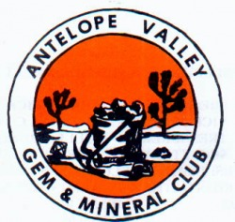 CHIP ‘N’ TUMBLE

_______________ _____ ________ _____________ December 2014

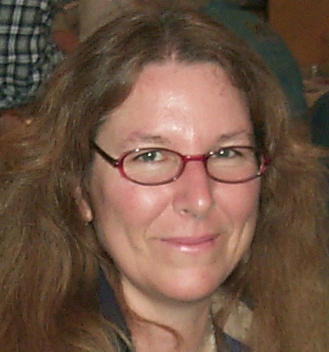

PRESIDENT’S MESSAGE
By: CJ Quitoriano

Hello fellow members!
It's that time of year again...Election time!!
We need to have any nominations in by the next meeting, and nominations will also be accepted from the floor.
The offices to run for are:
President-CJ Quitoriano is willing to run, unless someone else is willing and able!
Vice President- is up for nominations.
Treasurer- Susan Walblom is currently our treasurer and doing an awesome job!
Secretary-Lorelei Paland is currently our Secretary, and also doing an awesome job!
We have 5 Director spots, one of which is currently vacant, but anyone can run, so think about it!
The current officers are not in stone, so please think about running for office, it's a great way to get to know everyone, and we have great times at our board meetings!
Check your by-laws for the description of the offices, you can also become a chairperson for any of the chair positions. Check the by-laws, and if you see something you would like to do, please ask me about it!
This is YOUR club, and volunteers are greatly appreciated!!!
It is almost time for our holiday party!!
We have reserved a room at the Hibachi Grill in Palmdale. We will have a raffle and gift exchange!
Our gift exchange is a "white elephant" style exchange where each member brings a wrapped gift valued from $15-$20. It doesn't have to be rock related, but it can be!
Each gift bearer is given a ticket, the first person whose ticket is drawn, gets to open a gift, the next person can either open a new gift, or steal the first gift! If a gift is stolen, then the person who lost it, either gets to steal from another person, or open a new gift. Each gift can only be stolen a total of three times, and then that person gets to keep it. It goes like this until all the gifts are opened. That's when the trading begins... ;-)
This year we will also be holding a raffle. The tickets will be available at the next meeting and at the party. They will be $1 per ticket, or 6 for $5. So remember to bring your ca$h to the party as well as the meeting!!
On a sadder note, one of our longtime members, Mel Koppers, passed away in October. He will be missed for sure!
See you all at the next meeting!
CJ

Calendar of Events!
11/25 General Meeting
12/9 CLUB CHRISTMAS PARTY
12/16 Board Meeting

DUES ARE DUE!!!
Please pay your dues at the November General Meeting! or
Mail by December 1st to: Susan Chaisson-Walblom
42122-52nd Street West Quartz Hill, Ca 93536
Adults-$15 & Juniors (8-17)-$5

November Program
Wire Wrap Demonstration By: Christine Janicki



Articles
Page 1 ……….President’s message
Page 1………..March Program
Page 1………..Calendar of Events
Page 1………..Rock of the Month
Page 2………..Refreshments
Page 2………..Club Website
Page 2………..Birthdays & Anniversaries
Page 3………..General Meeting Minutes
Page 4…….….Board Meeting minutes
Page 4………..CFMS News & Shows
Page 5……….AV G&M Board & Directors

Welcome to our new
Club Members!!!
Lorraine Barnard
Christine Janicki
Sarah & Stella Janicki (Jrs.)


November
Refreshments
Provided by:
Jonathan Numer
Ellen Niduvitut

Gold is the only metal that doesn’t rust, even if it's buried in the ground for thousands of years.

Rock of the Month!

Don't forget to bring something that you found, bought, made, or somehow obtained THIS MONTH to the meeting.
Display your item(s) and everyone will vote on their favorite display! At the end of the year the person winning the most times during the year will take the plaque home!

HAPPY
BIRTHDAY & ANNIVERSARY
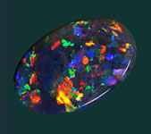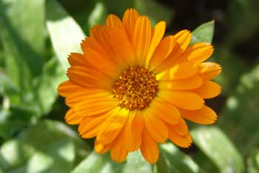
Opal Marigold

NOVEMBER
11/6 Danny Watts
11/7 Lana Haven
11/12 Sarah Janicki
11/12 Jerry Paland
11/12 Olivia Miseroy
11/13 Mary Black
11/29 Ellen Niduvitch
11/30 Elaina Cologna

Anniversaries

11/21 Danny & Vivian Watts

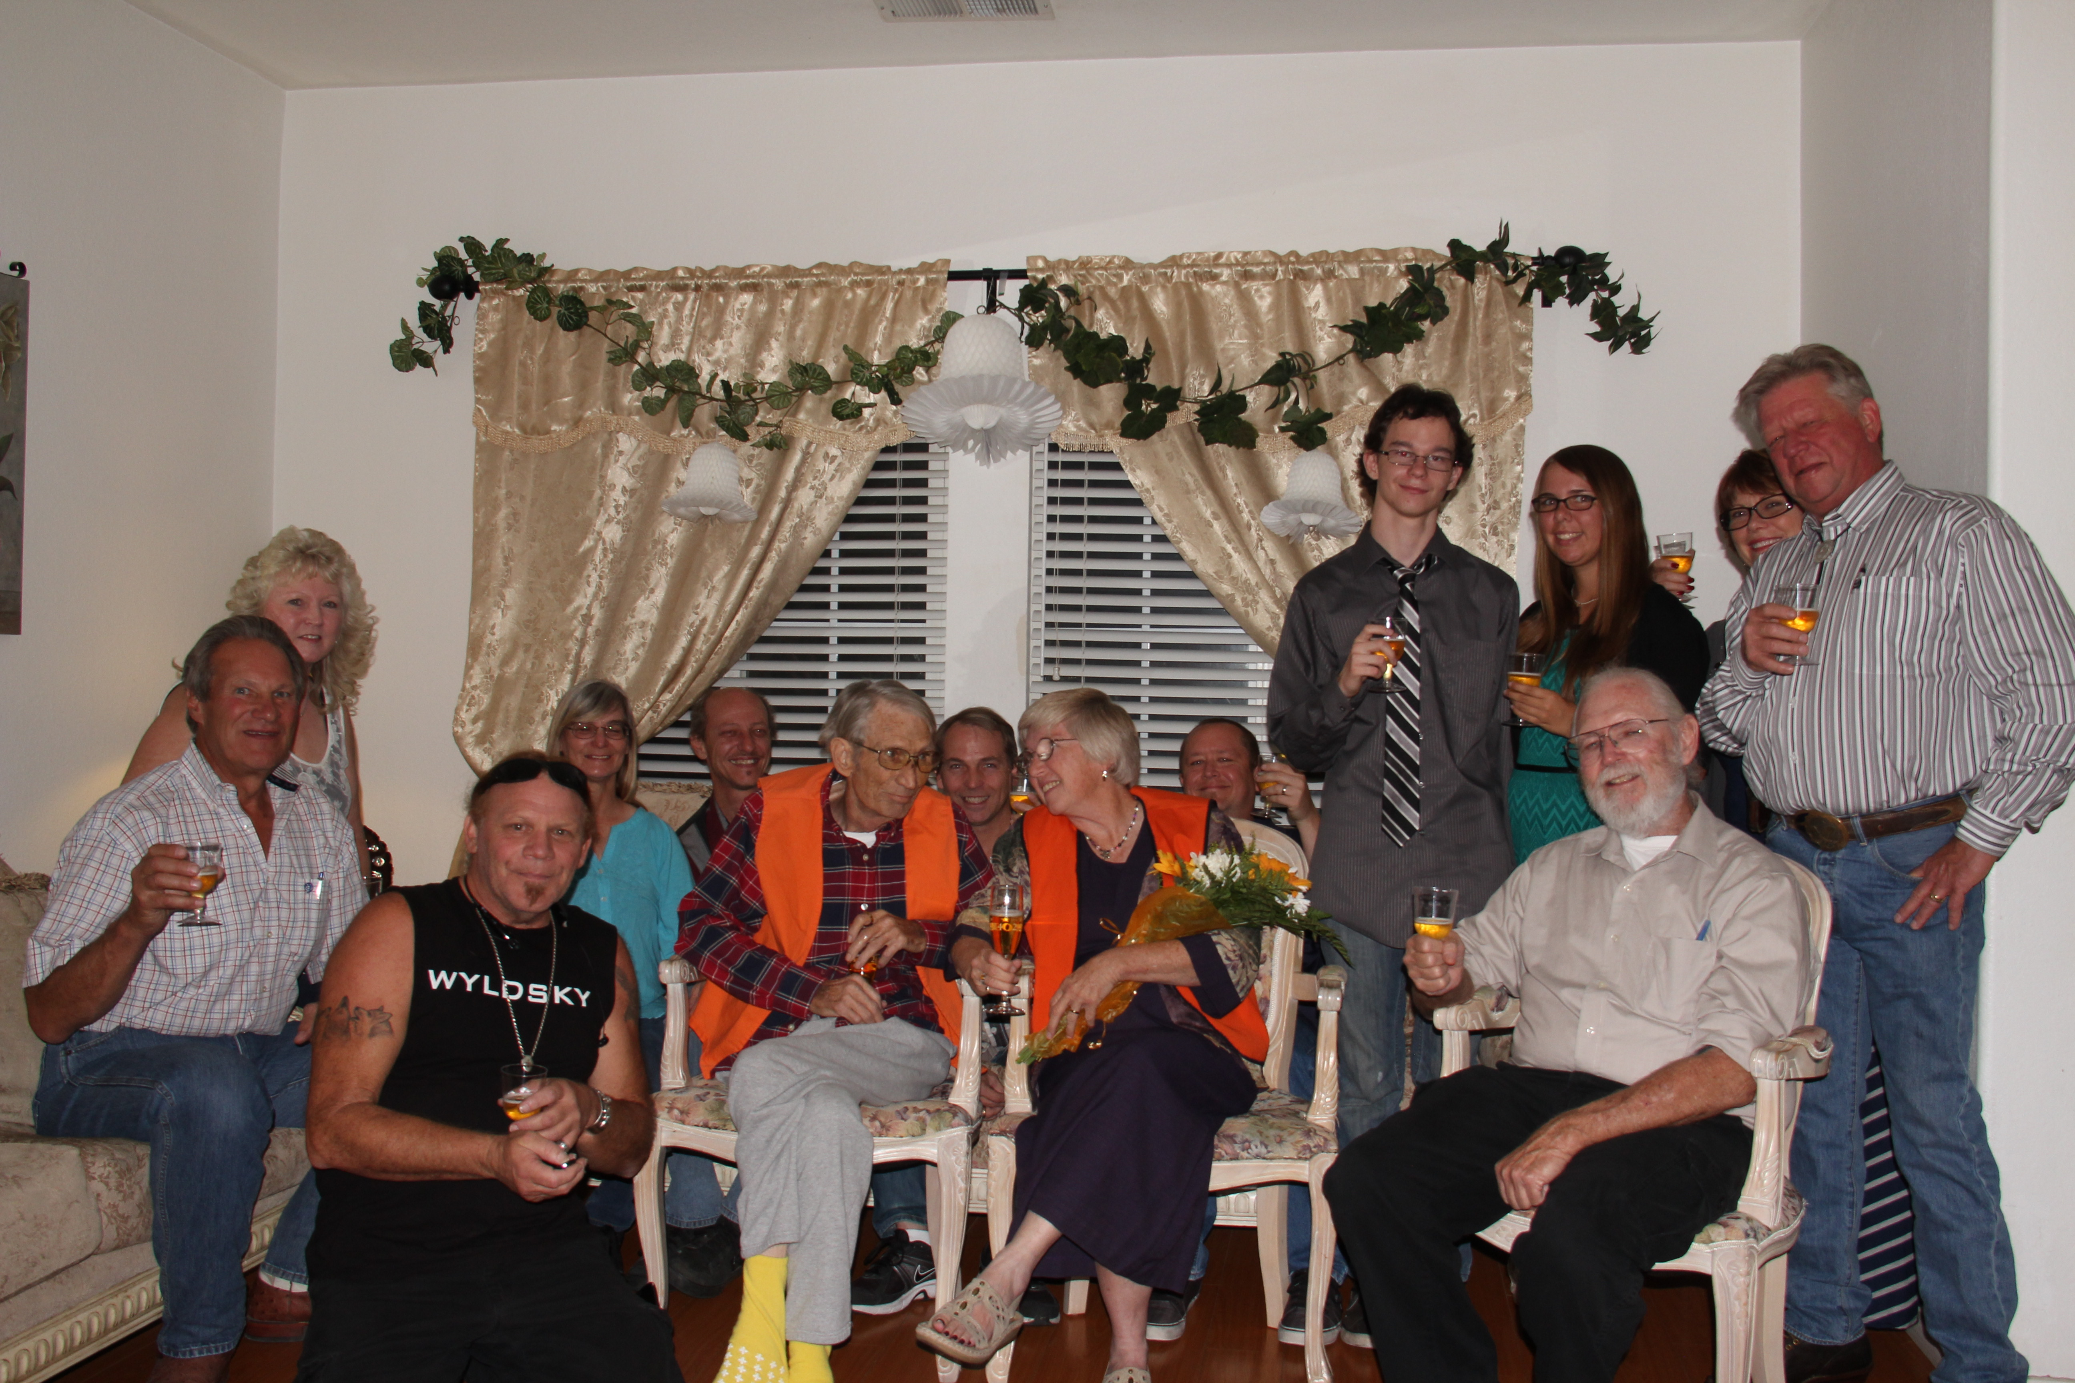

Mel Kopper

On Saturday October 4th my best friend & rock hounding cohort fell and hit his head and was admitted to the hospital. Results of the x-rays and subsequent CT scan showed brain tumors and stage 4, metastasized cancer, among other things. The following Wednesday he asked me to marry him. Sunday we moved him into hospice care. Wednesday, we started planning a wedding. Mel and I wed on Saturday 18 October. The attached picture shows Mel and I, vividly clad in the AV Gem & Mineral Club vests, which is how we met about 10 years ago. We are surrounded by a friend who conducted the services, Mel’s sons, brother, and grandson, my friend who talked the preacher into presiding, some wives & girlfriends, and a friend of Mel & me who took all the pictures. Everyone in this picture contributed to the success of this event. It was quite nice.
Luv, Pamela

Save Gem Hill & Lonely Butte



YOU CAN HELP!!
FOLLOWING IS A SUMMARY YOU CAN COPY AND EMAIL OR PRINT FOR DISTRIBUTION TO YOUR CLUBS & FRIENDS. Print it as a flyer and take it to any shows you may be attending!
Rockhounds are in danger of losing two well-known local collecting spots to solar and/or wind farm development. Both Lonely Butte aka Brown Butte and Gem Hill lie directly in the Development Focus area of the DRECP. Both of these spots are in the Gem Trails of Southern California books and have been used by Rockhounds for decades.
The Desert Renewable Energy Conservation Plan (DRECP), a major component of California's renewable energy planning effort. It is designed to streamline and fast track the permitting process for huge solar and wind development in the California Deserts.
The required meetings for comments are currently in progress. Please attend if you can and make it known we want to be able to continue to access these areas and keep them open for future generations. For meeting locations go to http://drecp.org.
Public comments can also be submitted in writing through January 9, 2015. Go to the website: http://drecp.org for information on how to comment, maps and much more.
A FB page - SAVE GEM HILL & LONELY BUTTE has been created to unit Rockhounds in this endeavor
Specific information on these two location you may want to use in your comment follow:
BROWN BUTTE AKA LONELY BUTTE:
Township 10 N
Range 11 W
Sections 2, 3, 10, & 11.
Note section 2 is all BLM and Section 10 is mostly BLM land.
GPS- 34.976746 Longitude
-118.024271 Longitude
GEM HILL:
GPS at one area of collection:
34.926220 Latitude
-118.22122 Longitude
Township 10 N
Range 13 W
Sections 26, 27, 34 & 35

NOMINATION
&
ELECTION TIME
Please contact Steve Wittick (661) 718-3880
if you are interested in running for one of these AVG&M Board positions:
President
Vice President
Secretary
Treasurer
5 Directors

CLUB WEBSITE
www.avgem.weebly.com
You can check out the club’s website at: http://avgem.weebly.com. As I am able to get updated information, I update the website as well. And just a reminder - I welcome any help with photos from the general meetings and events, award winning items and winners, and field trips to help keep the website current. Rhonda

Intelligent people have more
zinc and copper in their hair.

*REMEMBER *
ARTICLES FOR YOUR NEWSLETTER ARE DUE TO THE EDITOR BY THE 3rd SATURDAY OF EACH MONTH!!!

AV Gem & Mineral Club
Board Meeting Minutes
October 14, 2014
President CJ called the meeting to order at 7:10 p.m.
In attendance were: CJ Quitoriano, Ray Quitoriano, David Walblom, Steve Wittick & Susan Chaisson-Walblom.
Steve moved to accept the minutes as published, Ray 2nd the motion, passed.
Susan gave the treasurer report. The checking account balance is $9,973.29 and the savings account balance is $15,160.95.
The Club Directors need to work on the 2015 budget.
Susan will check on insurance for the club house and the utility trailer.
Newsletter articles are due by this Saturday.
The CFMS Bi-annual meeting will be held in Visalia on November 8th.
Field trip to the Sierra Paloma claim is Saturday, October 18th.
9 new membership badges are ready to be handed out at the next general meeting.
The new Refreshment Chairman is Jenny Baker.
The October Program will be a demonstration on hard stone carving.
David will look into purchasing an educational video on the Death Valley.
CJ is checking with Lancaster High School to confirm the dates for next year’s Club Show.
The 2015 Antelope Valley Fair will be August 21-30, 2015.
This year’s Christmas Party will be held at the Hibachi Grill by the Mall in Palmdale. Date to be decided. There was discussion on the possibility of members paying for their own meals.
Elections are right around the corner. We need to get nominations.
New business: none
Old Business: none
Ray moved to adjourn at 8:06 p.m., Steve 2nd the motion, passed.

Antelope Valley Gem & Mineral
General Meeting Minutes
October 28, 2014 Minutes

The meeting was brought to order at 7:15
Flag salute
Announcements - Mel Koppers, one of our members passed away last week. Services will be posted on our website for those wishing to attend.
Welcome - 38 members and 5 guests. New members this month are Alex Borchest, Chris and Paula Smith and family, Terry Ryan, David and
Cynthia Haven and family, Olivia Miseroy, Lucas Karnes, Christine Janicki and family.
Show in Oxnard this weekend and in Santa Ana next weekend.
Door prizes were won by Jonathan Numer, Sarah Janicki and Don Reed.
Badge drawing of $5 was won by Vivian Watts.
Program - Jonathan is demonstrating how to carve rocks.
BREAK - snacks and buy raffle tickets
Treasurer’s report - Balanced with the back but there are a few outstanding checks that need to be cashed.
Bulletin - please send in articles by the second Saturday before each meeting. A paper is being passed around with names and addresses.
Please check yours and make changes if needed.
Federation Director - There is a meeting Nov. 8th CFMS elections
Zzyzx applications need to be turned in ASAP
CFMS show in Lodi on June 12-14
Field Trip Chairman still needed. There is no field trip planned for Nov. at this time.
Refreshments for next month - Jenny to call people to remind them
Program for next month - Christine Janicki with demo and teach wire wrapping.
Publicity - made contact with a new person at the AV Press. Meetings are being published.
Scholarships - Vivian made a motion to accept one more that had been lost in the mail, Don Reed seconded it and everyone agreed.
Future Rockhounds - Jonathan is having a group of home schoolers come out to the Devil’s Punchbowl to educate them about rocks. We also need ideas and things for the Jr. Rockhounds to do during the meetings.
Spring Show - last weekend in April 2015
Poppy Festival the week before
Old Business - Christmas will be held at the Hibachi Grill by the mall on Tuesday, Dec. 9th
Elections are coming up next month
2015 dues are due next month.
New Business - Ruth Hidalgo told us that we are in danger of losing Gem Hill and Lonely Butte as places to explore and find rocks. They are on BLM land and being considered for solar and wind farms. We need to help fight this and keep it from happening.
Next Board meeting is at Jerry and Lorelei’s on Nov 11th at 7 pm
50/50 drawing of $40 was won by one of our guests, Oscar Cruz
Rockhound of the moth is Vivian Watts.
Meeting was adjourned at 9:00



The Earth gets 100 tons heavier every day due to falling space dust.

SLABS
The Club needs your help! We need any extra slabs you have laying around. The slabs will be used to make critters for the spinning wheel at the Poppy Festival-Our Show-Fair booth!
THANK YOU! THANK YOU! THANK YOU!

CLUB WEBSITE
www.avgem.weebly.com
You can check out the club’s website at: http://avgem.weebly.com. As I am able to get updated information, I update the website as well. And just a reminder - I welcome any help with

2014 Local CFMS Show Listings

Quartzsite Arizona
Tyson Wells January 2-February 8
Pow Wow January 21-25

