_______________ _____ ________ _____________ April 2015

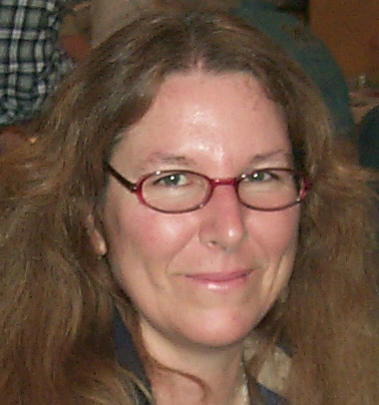

PRESIDENT’S MESSAGE
By: CJ Quitoriano

Hello fellow rockhounders!
Ray and I are currently enjoying the Hawaiin Islands and we will miss the March meeting.
We will be sure to scout out some rock hounding spots while we're there and bring back news of all the good spots...
Marcia is going to be filling in for me, so be kind.
The program this month will be given by Steve, who is going to show everyone how to set up a case for the show and the fair.
Remember, we have a trailer load of cases now, so everyone is encouraged, and almost expected, to put a display in the show!
Our field trip in February was a rousing success! We had 11 members come out for the day and we all collected a lot of nice material for our grab bags. We went for Silver lace onyx, and Lavic Sighting Jasper and agate.
Our show is in April, so no field trip in April.
We also had a great workday where we stuffed rock bags, put together necklaces, and filled capsules for the mystery mine.
26 members came and we had a wonderful potluck of yummilicious food!!
We will be having another work day on April 4th at 10AM.
This will also be our last opportunity before the show and poppy festival to go over last minute details. So please try to make it we still have a lot to go over.
Bring rocks and don't forget to bring some bags! We filled all that we had at the last work day.
Be sure to sign up for a shift at the poppy festival. Marcia will have the signup sheet.
She will also have a signup sheet for the show.
We need volunteers to work the children's booth, the kitchen, silent auction, and security.
Speaking of security, I would like to ask for a volunteer to head our security. As head you would be responsible for finding someone to spend the night on Friday and Saturday and to walk around the show and keep an eye out for shoplifters. So far we have no one to do that for us, so please consider it and let Marcia know if you're interested.
Ray will be BBQing his famous chicken on Friday night, and we need everyone to bring a side dish and/or dessert for dinner.
We also need folks to bring baked goods to sell during the show. Cookies, brownies, cakes, pies, etc. are appreciated.
Don't forget to bring slabs for those who are making critters for the spinning wheel. And don't forget to make critters!
Have a great meeting, I wish we could be there! I look forward to seeing all of you at the work day on April 4th!
CJ

Calendar of Events!
3/10 Board Meeting
3/24 General Meeting
4/4 10a.m. Work party
4/14 Board Meeting
4/25 & 26 CLUB SHOW
4/28 General Meeting

March Program
Steve Wittick will be giving a program on designing a case liner!



March Refreshments
provided by:

Snacks:
Jenny Baker
Elaine Cologne
Drinks:
Lorraine Barnard

Articles
Page 1 ……….President’s message
Page 2………..Birthdays & Anniversaries
Page 2………..Ten Rarest Gemstone
Website
Page 3………..Meeting minutes
Page 4………. Cutting of Lithophysae
Page 5………..AV G&M Board & Directors
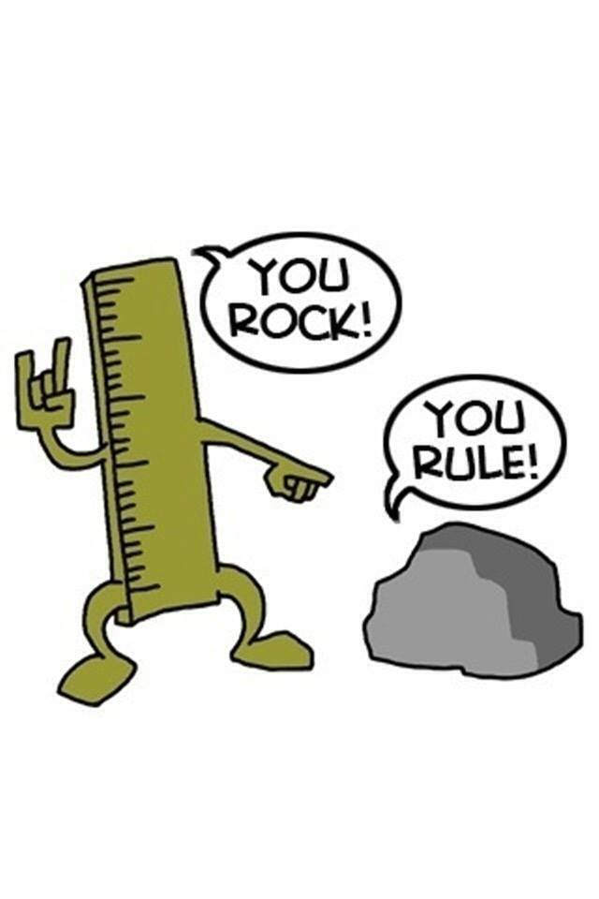
Ten Rarest Gemstone Minerals
10. Painite (Myanmar)
9. Alexandrite (Russia)
8. Tanzanite (Kenya)
7. Benitoite (California)
6. Poudretteite (Quebec)
5. Grandidierite (Madagascar)
4. Red diamonds
3. Musgravite (Australia, Madagascar)
2. Jeremejevite (Namibia)
1. Red Beryl (Utah and New Mexico)

WELCOME NEW MEMBER

Grace Fink




MARCH HAPPY
BIRTHDAY & ANNIVERSARY

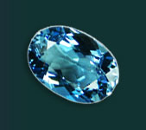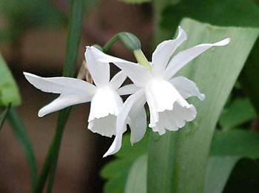
Aquamarine Jonquil

Birthdays

3/2 Sonny Nuduvitch
3/10 Ruth Hidalgo
3/20 Susan Chaisson-Walblom

Anniversaries

3/18 Sheila & John Berger
3/22 Susan & David Walblom
3/28 Rhonda & Ed Hedgecock

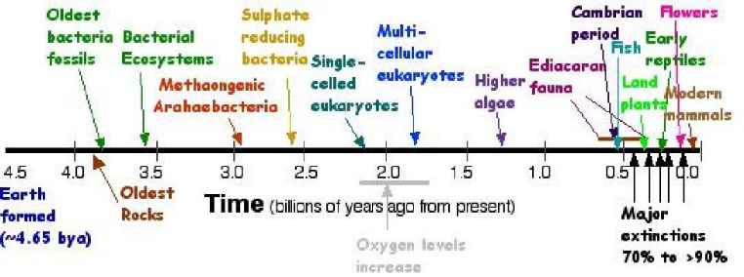
Via: Del-Air Monthly Rockhounder Review

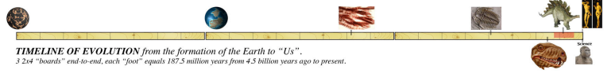

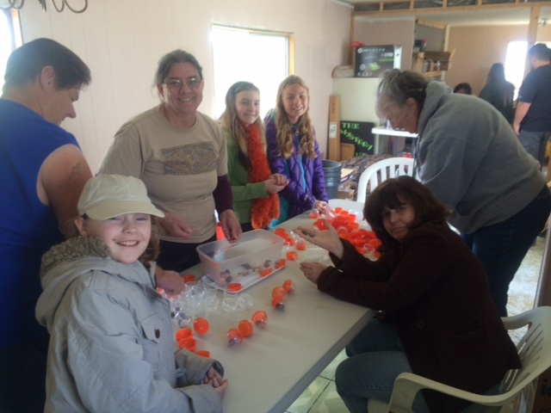
WORK DAY AT THE WORKSHOP!

CLUB WEBSITE
www.avgem.weebly.com
You can check out the club’s website at: http://avgem.weebly.com. As I am able to get updated information, I update the website as well. And just a reminder - I welcome any help with photos from the general meetings and events, award winning items and winners, and field trips to help keep the website current. Rhonda

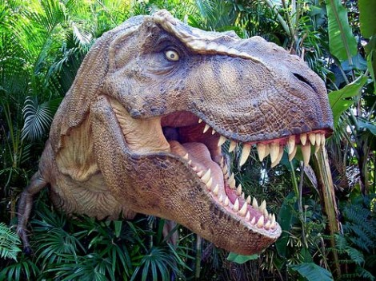

ARTICLES FOR YOUR NEWSLETTER ARE DUE TO THE EDITOR BY THE 3rd SATURDAY OF EACH MONTH!

Antelope Valley Gem & Mineral
February, 2015 General Meeting Minutes
Not available

Antelope Valley Gem & Mineral
March, 2015 Board Meeting Minutes
Not available

2014 Local CFMS Show Listings

March 28 & 29: TORRANCE, CA
South Bay Lapidary & Mineral Society
Ken Miller Recreation Center
3341 Torrance Blvd. (off of Madrona Ave.)
Hours: Sat. 10-5; Sun. 10-4
Richard Egger (310) 291-9855
EGGERJ87@gmail.com

March 28 & 29: ROSEVILLE, CA
Roseville Rock Rollers G&M Society
Roseville (Placer County) Fairgrounds
800 All America City Boulevard
Hours: Sat. 10 – 5; Sun. 10 – 4
Gloria Marie (916) 216-1114
gloriarosevillerockrollers@gmail.com
www.rockrollers.com

March 28 & 29: ANGELS CAMP, CA
Calaveras Gem & Mineral Society
Calaveras Fairgrounds
101 Frogtown Road
Hours: Sat. 10-5; Sun. 10-4
Robin Williams (209) 728-8277
amy95247@yahoo.com
calaverasgemandmineral.org

How to Determine Proper Orientation for Successful Cutting of Lithophysae:

Biconoid thundereggs-- eggs with a biconic core present a special problem. Most of these eggs will yield a face with a high degree of matrix if not cut properly. However, the pressure ridges left behind when a spherulite degases into a lithophysa are the key. Cut along the pressure ridge in a biconoid to achieve a larger agate face. Pressure ridges are a key to cutting orientation in any egg in which they are found on its surface.
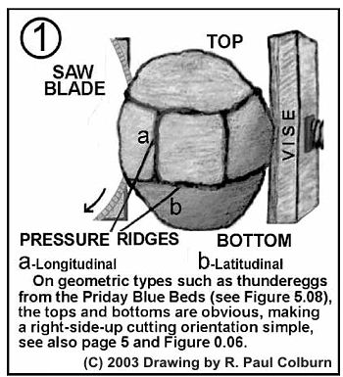

Most nodules and geodes of any species have features on their surfaces that an experienced lapidary artisan can identify by sight for cutting so as to capture all of the best features within. For example, many thundereggs (lithophysae) have lines known as flow bands on their exteriors and, unless a deposit has been deformed prior to filling, a cut made perpendicular to the flow banding and through the long axis (for the widest face) will yield a cut face showing the sequences of agate, waterline "floors," and stalactite deposition "right side up." If a formation has been tilted by a diastrophic event, subsequent filling will be at odds with both the flow bands and the long axis-- which can make orientation difficult, but not impossible.
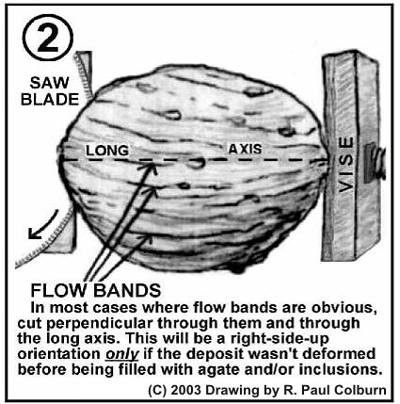

In any case, a fool proof method can be used to determine a proper orientation for any eggs dug directly from the material in which they form: While digging, when you "hit" one, carefully uncover enough of it to see the top and front, without removing it from in situ. Mark the top and draw a line towards you or a compass point with a broad black felt-tip marker. Record the compass point and mark every nodule the same way. After cutting just a few, an angle departing from that mark will be found which will expose the most interesting features, and with care, the value and beauty of your nodules will be increased.
More detailed information can be found in my forthcoming book, The Formation of Thundereggs.

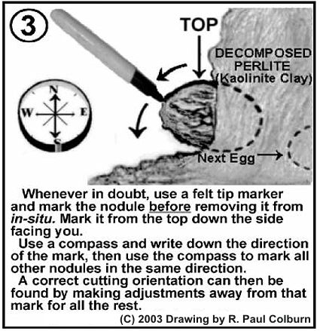

geodekid@zianet.com
This web page was created for the Geode Kid by:
Carlton J Donaghe and Bill Boomhower



