
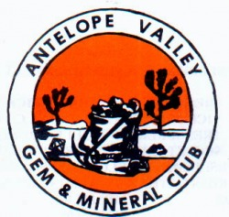 CHIP ‘N’ TUMBLE

_______________ _____ ________ _____________ April 2014



PRESIDENT’S MESSAGE
By: CJ Quitoriano

Hi Everyone!
It's getting close to show time, and we will be discussing that and the Poppy Festival at the next meeting.
We will need volunteers and sign up sheets will be available at the meeting.
We are planning a work day at the trailer to stuff grab bags, Saturday the 5th of April at 10 am. Bring any buckets of rock you have at home, we need lots of rocks!
We also need more slabs! If you happen to have a bunch of derelict slabs laying around, bring them to the meeting! We need lots of critters for the Poppy Festival and our show!

If you get this in time, there is a field trip to Kramer Junction scheduled for Saturday, March 22nd. We will be meeting at the McDonalds in Mojave at 8AM, and will meet up with the Tehachapi Club and others in Boron at 9AM.
We will leave the McDonalds parking lot no later than 8:15 AM, so be on time! We may also be joined by the Sierra Pelona club and go to their claim in the area!

On February 15th, we went to Gem Hill in Rosamond. Several club members attended, and we collected agate, jasper, and opalite! It was a good time for all!
See you at the meeting! CJ

MARCH PROGRAM
2nd half of the Rock Collecting of Rhodochrosite in Colorado video!

Calendar of Events!
3/22 Field Trip-Kramer Junction
3/25 General Meeting
4/8 Board Meeting
4/22 General Meeting
5/30-6/1 CFMS SHOW-PAMONA

March Rock of the Month!
Don't forget to bring something that you found, bought, made, or somehow obtained THIS MONTH to the meeting.
Display your item(s) and everyone will vote on their favorite display! At the end of the year the person winning the most times during the year will take the plaque home!

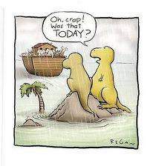
March
REFRESHMENTS
Will be provided by:
Carey Beasley & Mary Black
Thank you ladies!!!!
Articles
Page 1 ……….President’s message
Page 1………..March Program
Page 1………..Calendar of Events
Page 1………..Rock of the Month
Page 1………..Refreshments
Page 2…………Field Trips
Page 2…………Club Website
Page 2………..Slabs are needed
Page 3………..Birthdays & Anniversaries
Page 3…….….CFMS Web Scam info
Page 4 & 5….Meeting minutes
Page 5………..CFMS News & Shows
Page 6……….AV G&M Board & Directors



FIELD TRIPS

March 22 – Kramer Junction
We will be meeting at the McDonalds in Mojave at 8AM, and will meet up with the Tehachapi Club and others in Boron at 9AM.
We will leave the McDonalds parking lot no later than 8:15 AM, so be on time! We may also be joined by the Sierra Pelona club and go to their claim in the area!
January 2015 – Quartzsite, January 2nd

If you have an idea for a Club Field Trip, please let CJ or another Board Member know about it.

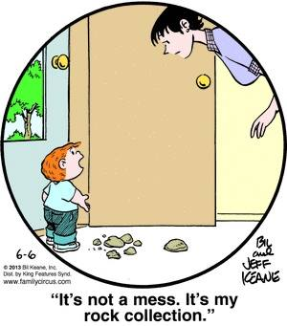

CLUB WEBSITE
www.avgem.weebly.com

Hi All, The website has been updated for now. As I get more information, I'll continue to make changes and updates to it. If you take pictures at a meeting or on a field trip, would love to have you send me a copy - I can use them here and there. Thanks! Rhonda



SLABS
The Club needs your help! We need any extra slabs you have laying around. The slabs will be used to make critters for the spinning wheel at the Fair!
THANK YOU! THANK YOU! THANK YOU!

HAPPY
BIRTHDAY & ANNIVERSARY

Happy Birthday!
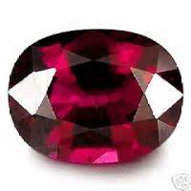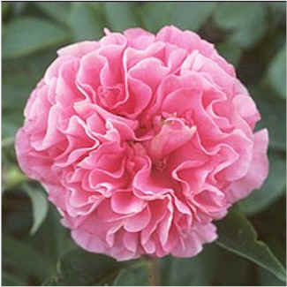
Garnet Carnation
January
14 Bonnie Forstner
17 Sandy Singleton

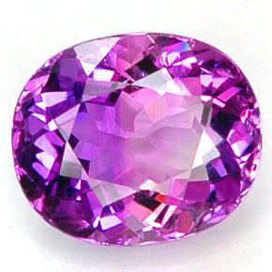
Ameythist
February
14 Katie Chaisson-Doull
20 Ed Hedgecock
26 Vivian Watts
March
2 Sonny Nuduvitch
10 Ruth Hidalgo
20 Susan Chaisson-Walblom
April
19 Shelly Thorn
29 Sophia Zieska

Happy Anniversary
3/18 Shelia & John Berger
3/22 Susan & David Walblom
3/28 Rhonda & Ed Hedgecock

*REMEMBER *

ARTICLES FOR YOUR NEWSLETTER ARE DUE TO THE EDITOR BY THE 3rd SATURDAY OF EACH MONTH!!!



WEB SCAM INFORMATION
To All Rockhounds
If you receive an email
with the Subject: CFMS Society Shows Invitation and Member pass Please just delete it, DO NOT OPEN
IT. This has been going around and it is NOT from the California Federation of Mineralogical Societies (CFMS). It is a Scam or worse yet a virus. Our CFMS Does not send out invitations to our
shows that require going to through a Hyperlink to an unknown website! Below is the text of the email as received. The person, Tom Dolmes, is not the secretary of our CFMS nor a member of any member club/society that we can find.Lorelei Paland.
Secretary
AVGMC
Dear Valued Member,
> �You have been invited to the CFMS Society Shows for
> February 27 2014. Please, download your invitation letter Click HERE
> �Please note that download is set to automatic. Please
> open letter to view Dress code, Your access code, Venue and
> directions.
> �Your presence is highly
> appreciated
> Thank you
> Tom Dolmes
> Secretary
> CFMS Society Shows
> 2014


Antelope Valley Gem & Mineral
General Meeting Minutes
January 2014 Minutes

The meeting was brought to order at 7:05
Flag salute. Those present 20 members, 5 guests
Lorelei read the minutes from the last meeting. Steve made a motion to accept the minutes as read seconded by Rhonda.
Treasurerʼs report- We need to set a budget for the year.
CJ reported that we spent more at Quartzsite then was budgeted for, but a vote was taken, and approved by the board, over the phone to raise the budget to $1,500. Only $1,300 was spent. The original budget was set at $1,000. We paid out four scholarships from the Fair proceeds Door prizes were won by Ron James, Ken Vaughn (a
guest) and Jonathan Numar Badge drawing of $5. was won by Vivian Watts. Since the treasurer is not present, it will be paid to her at the next meeting.
Program was presented by Jonathan Numar on the Devils Punchbowl and the things found in the area.
There will be a work day and pot luck at Ray and CJs on Sunday the 9th. Please bring slabs for critters
BREAK FOR REFRESHMENTS
Bulletin - Please send stuff into Susan. You can write an article or submit information that might be interesting to club members.
Federation news - CJ reported there is nothing new but remember the show is at the Pomona Fairgrounds May 31st - June 1st.
The 50/50 drawing of $18.50 was won by Danny Watts
Rockhound of the month was won by Everett
Business meeting will be held on Feb 11th at Jerry andLorelei’s
Meeting was adjourned at 8:50

Antelope Valley Gem & Mineral Club
Board Meeting Minutes
February 18, 2014

Meeting was called to order at 7:10 p.m.
Those present - C.J., Ray, Lorelei, Jerry and Steve
Fed show will be on May 31 - Jun 2
Ventura club would like us to advertise our show in their newsletter and we would do the same for them.
March field trip maybe to Acton on the 22nd Steve will check out the sight.
Program for Feb may or may not be the Lapis guy
Spring show - Lorelei made a motion to have C.J. order more dinosaurs, Steve seconded
Poppy Festival - Steve and Carey
Meeting adjourned at 7:33

Antelope Valley Gem & Mineral Club
General Meeting Minutes
February 26, 2014

Meeting called to order at 7:05 p.m.
Those present - 22 members - 5 guests
pledge to the flag
Motion to accept minutes made by Vivian Watts, 2nd by Ellen Niduvitch
Treasurer’s report given by C.J. - Currently $3557 in checking
Door prize winners - Ruth Hidalgo, Grace Becker and Dessi Vaughn
Badge drawing won by Vivian Watts - She got $10. $5 was owed from last months meeting
Program by Ron - Video on Rock collecting - Finding rhodochrosite in Colorado
BREAK voting on Rockhound of the month
Show and Tell - those who brought in items to share told a little about them
C.J. thanked everyone for coming to the work day
Sonny and Ray got the electric run out to the shop
Last months field trip to Gem Hill was a success. We collected a lot of stuff for the grab bags
The Federation Show will be May 31 - June 2 at the Pomona Fairgrounds.
Field trip for March will be on the 22nd to Kramer Junction
Stoddard Wells show is Mar 7 - 9 from 9-5 There will be a field trip on Sat to collect tri-colored marble. More info at VVGMC.org
Refreshments for March - Carey
Ventura and Monrovia shows this coming weekend, March 1st and 2nd
Program next month will be the second half of the video we watched tonight.
Scholarships - received one thank-you letter and 1 application for next year.
Spring Show - We have dinosaurs to put on slabs - take some home to make critters for the show. Bonnie brought in some slabs. The saws are going at Ray and CJ’s making more slabs. Steve and Betty have already made 200 bags. Ray picked up some fluorite from Acton Canyon for the bags. Bag filling will be sometime in early April.
POPPY FESTIVAL - Steve will set up and open - needs volunteers Fllyers will be coming out next month.
ROCK SHOW - will be May 10 - 11 We will have sign ups next month, Displayers are needed
The March board meeting will be held at Jerry and Loreleiʼs on March 11th
50/50 drawing won by Ray - $19 Money goes towards Christmas raffle. We need to be looking for a new place this year.
Rockhound of the month goes to Vivian

Meeting adjourned at 8:48
Antelope Valley Gem & Mineral Club
Board Meeting Minutes
March 11, 2013

Meeting was called to order at 7:29
Those present - Ray & C.J., Jerry & Lorelei, David & Susan and Steve
Susan made a motion for Steve to buy the parts to fix the saw that was donated, not to
exceed $300 - Ray seconded
Treasurerʼs report - Paid $651. in sales tax for 2013
Paid $304 to CFMS for sues and insurance for 2014 for 35 members
Field trip for March to Kramer Junction
Membership - New members Ken & Dessi Vaughn and Harry Becker
Rejoining were Ruth Hedalgo and Paul Hobbs
March program will be the 2nd half of the video we watched last month unless Ron can
get the guy to come talk to us about the Lapis on Mt Baldy.
Spring Show - everything is moving right along C.J. just needs to get the contract into
the city.
Talked about making a new attraction for the kids - a mine with an ore cart going in one
side with 50cents in it and coming out the other side with a rock. Jerry volunteered to
make the ore carts.
Poppy Festival - Need to get the contract in by March 14th
Rick Wade - Dinosaur man for the Spring Show - one day - Susan will email him with
the day and time
Spring Show - Talked about putting on the flyer that we will be giving the first 50 Moms
a bag of rock candy
Meeting adjourned at 8:25


2014 Local CFMS Show Listings

March 29 & 30: TORRANCE, CA
South Bay Lapidary & Mineral Society
Ken Miller Recreation Center
3341 Torrance Boulevard
(Entrance on Madrona Avenue)
Hours: Sat. 10-5; Sun. 10-4
Craig Polliard & Chris Lemaster
(310) 533-4931
CraigPolliard@yahoo.com
www.palosverdes.com/sblap
April 11, 12 & 13: VISTA, CA
Vista Gem & Mineral Society
Antique Gas & Steam Engine Museum
2040 N. Santa Fe Avenue
Hours: 9am – 5pm Daily
Ray Pearce (760) 726-7579
raysrocks@cox.net
vistarocks.org

April 26 & 27: THOUSAND OAKS, CA
Conejo Gem & Mineral Club
Borchard Park Community Center
190 Reino Rd. at Borchard Rd.
Hours: 10-5 Daily
Rob Sankovich (805) 494-7734
rmsorca@adelphia.net
http://www.cgamc.org/



KNOW YOUR ROCKS
Leaverite: Also known as Dropite, Junkite, and Crudite. This type of rock should be discarded immediately. It constitutes 90% ofmost rocks. This includes Sourgrape Agate and Mutilated Quartz.
Sack Rock: This is material that is stuffed into a sack but falls from the top as the bearer struggles back to the car. If taken home, it will be tossed into a corner and forgotten.
Wonder Rock: You always wonder why you brought it home and where you found it.
Braggin’ Rock: Also called Pocket or Eating Rock. This material is licked, rubbed, spit upon, and fondled until it assumes a near polish and is frequently passed around for admiration.
@#$%& Rock: A large, heavy, possibly angular rock that falls on your foot as soon as you have removed your hiking boots.
The Rock Collector, 5/08; via Shawnee Slate, 1/13;
via Rocky Mountain Federation News, Feb 2013
Ogden Rock & Gem Club Vol.41 Issue 3 March 2013 Behive Buzzer

