2024
Antelope Valley Gem & Mineral Club’s
Gem, Mineral & Jewelry Show

Saturday, May 4, 2023 10-5
Sunday, May 5, 2023 10-4

*FREE ADMISSION & FREE PARKING*
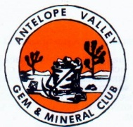
Antelope Valley Fairgrounds
2551 West Ave. H, Lancaster, CA 93536

Raffle, Silent Auction, Kid’s Activities, Demonstrations, Door Prize Drawings

Vendors with something for everyone!
Rocks-Beads-Minerals-Jewelry-Gems
Crystals-Tools-Books-Much Much More

